**Final Team Project**

# Designing Advanced Data Architectures for Business Intelligence

Group 13

Nitish Belagali- 002645514

Shruti Dhamdhere- 002812094

Shivpriya Mane- 002850626

Christina Daniel- 002833358

**PART 1:**

Ydata Profiling:

Report for Austin:

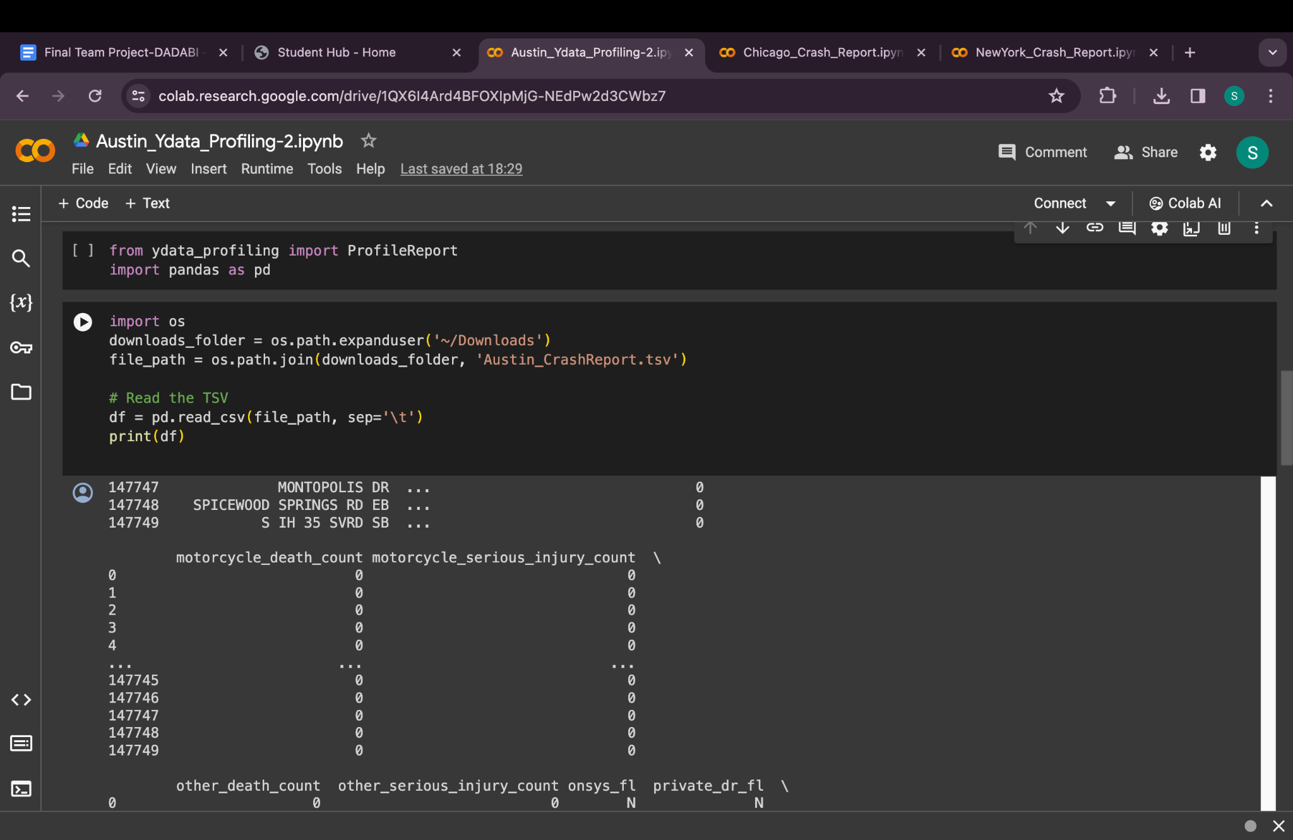

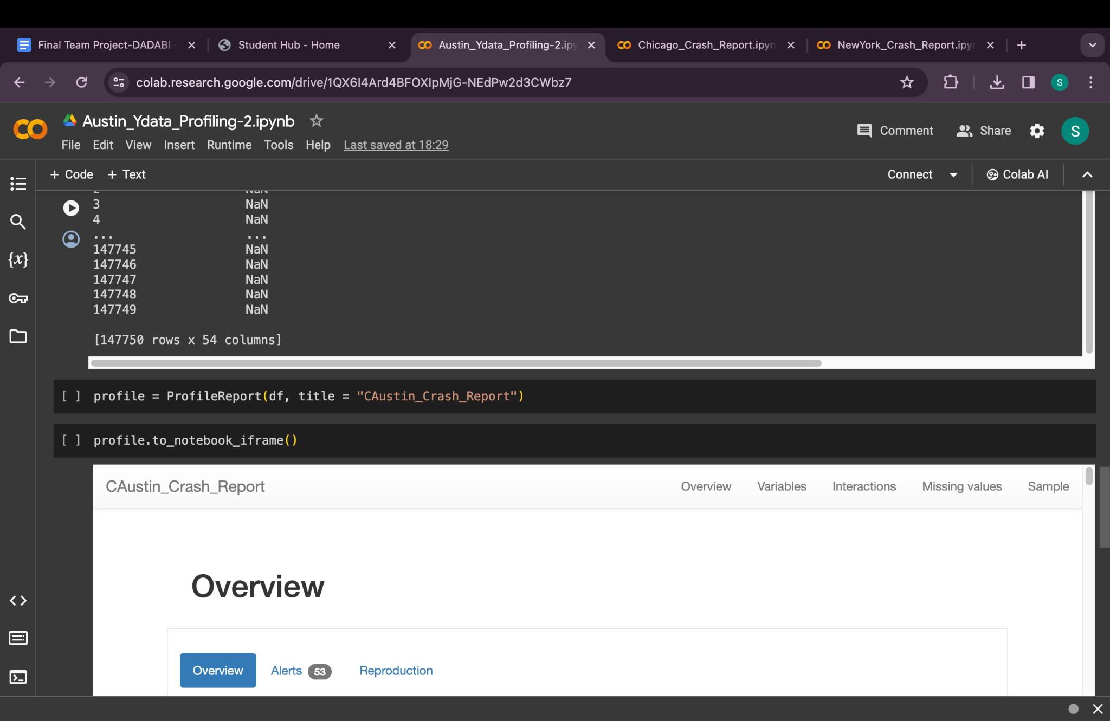

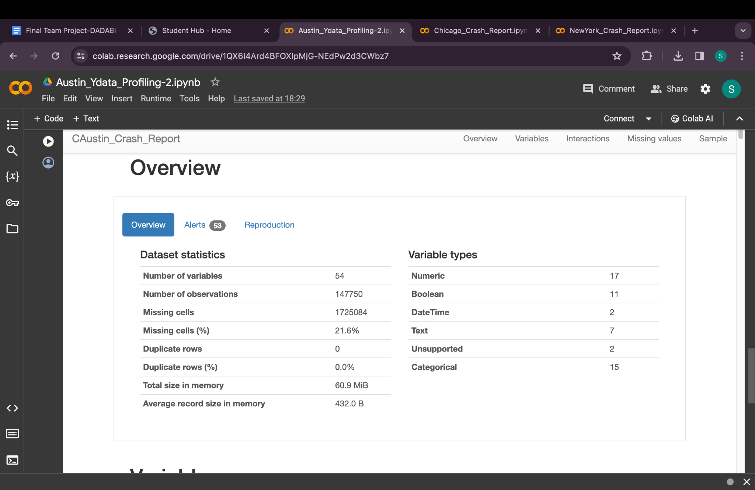

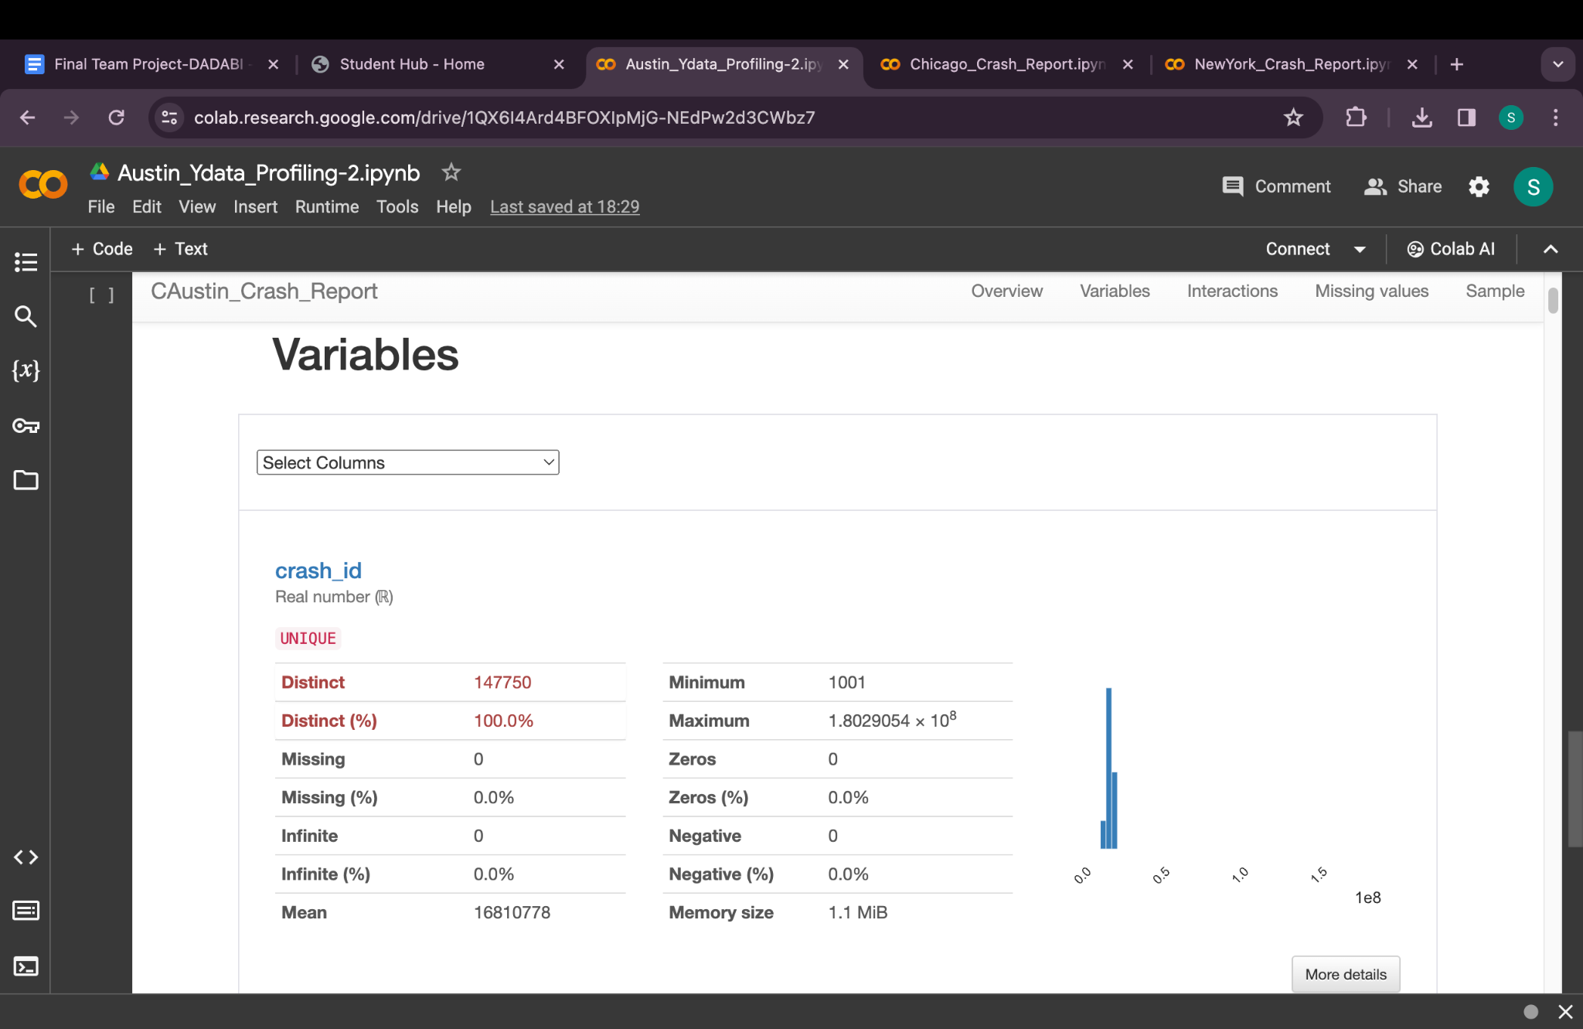

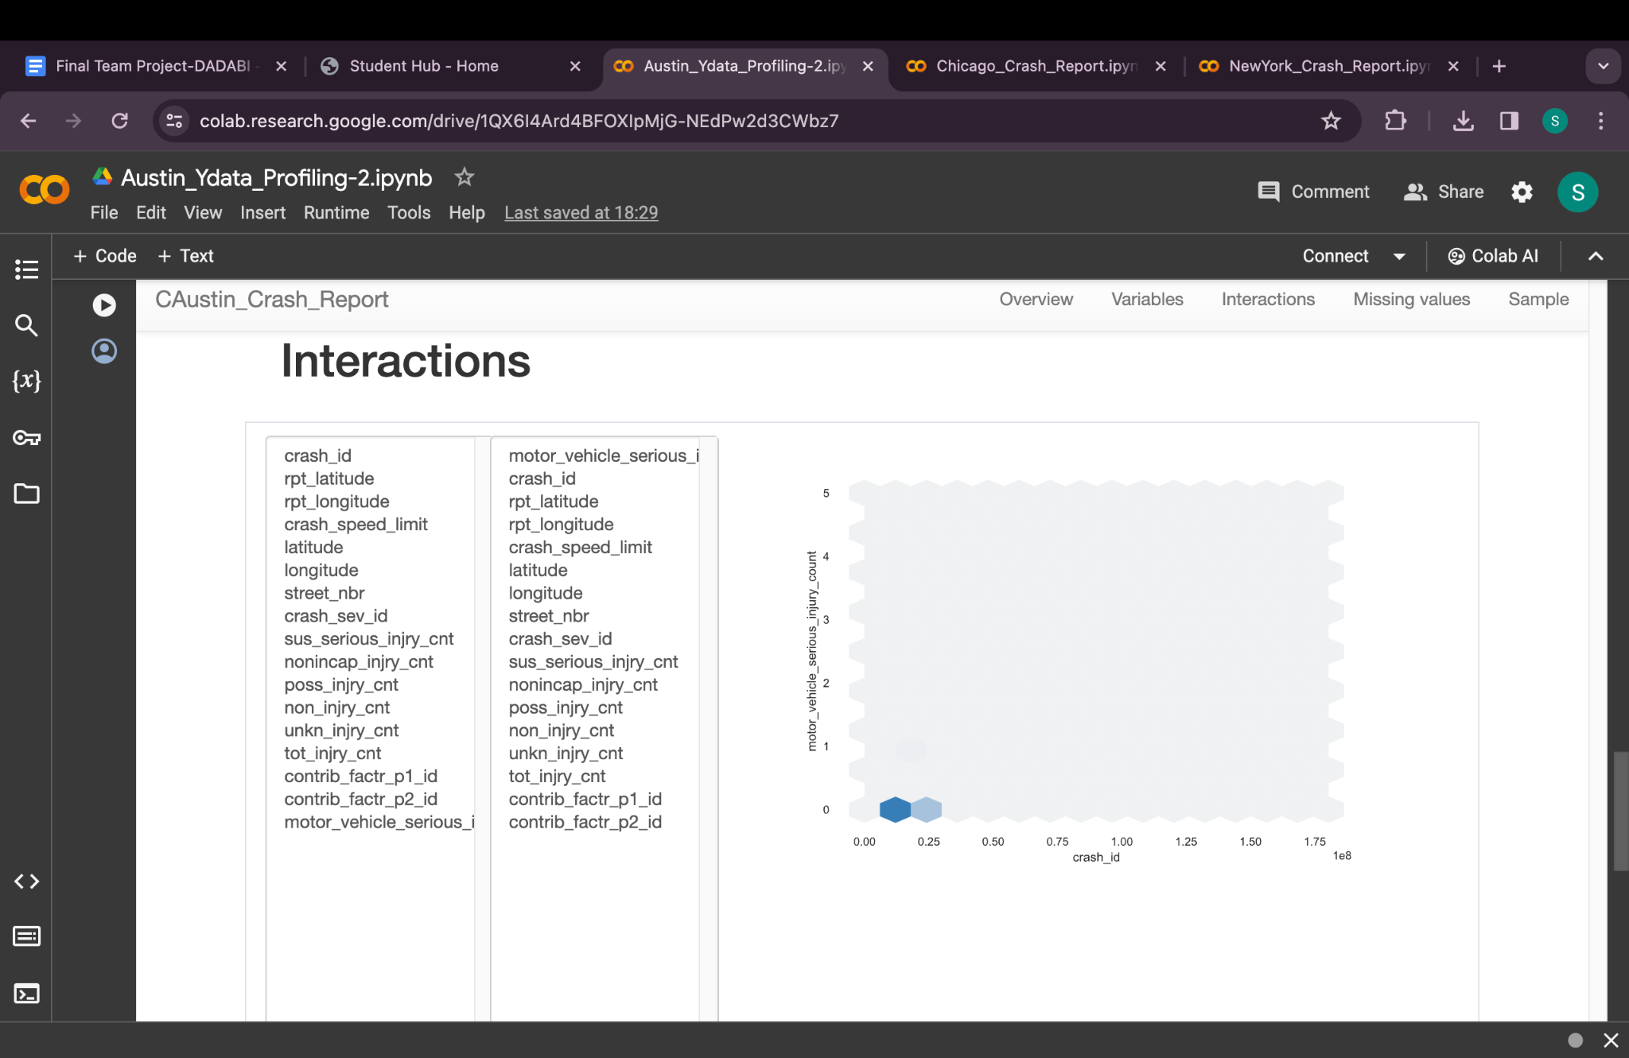

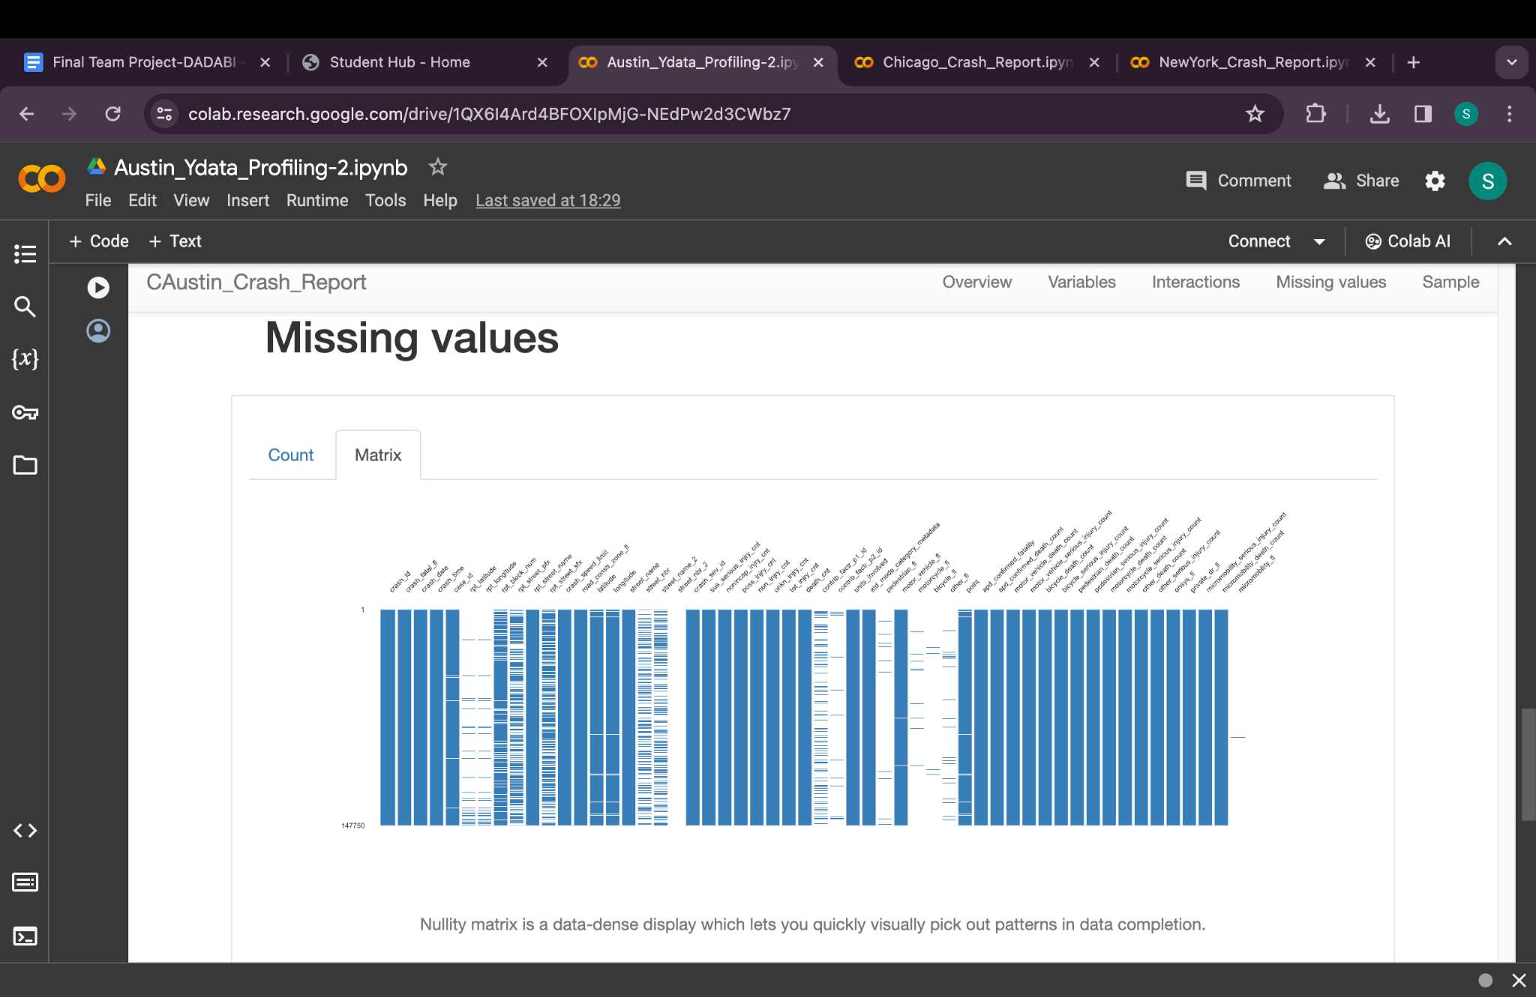

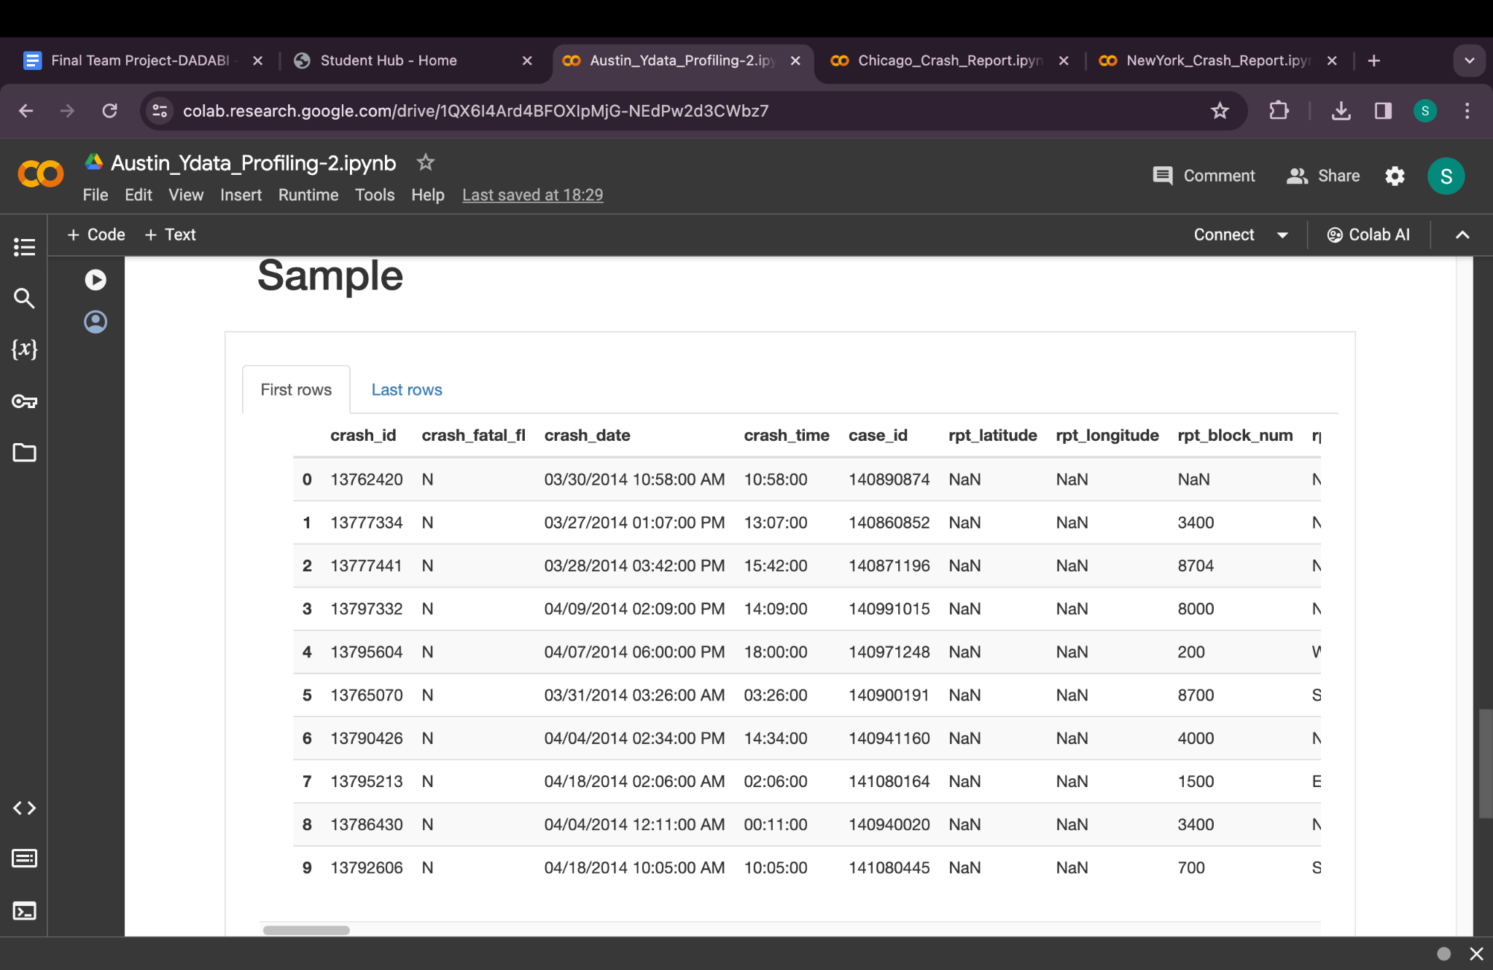

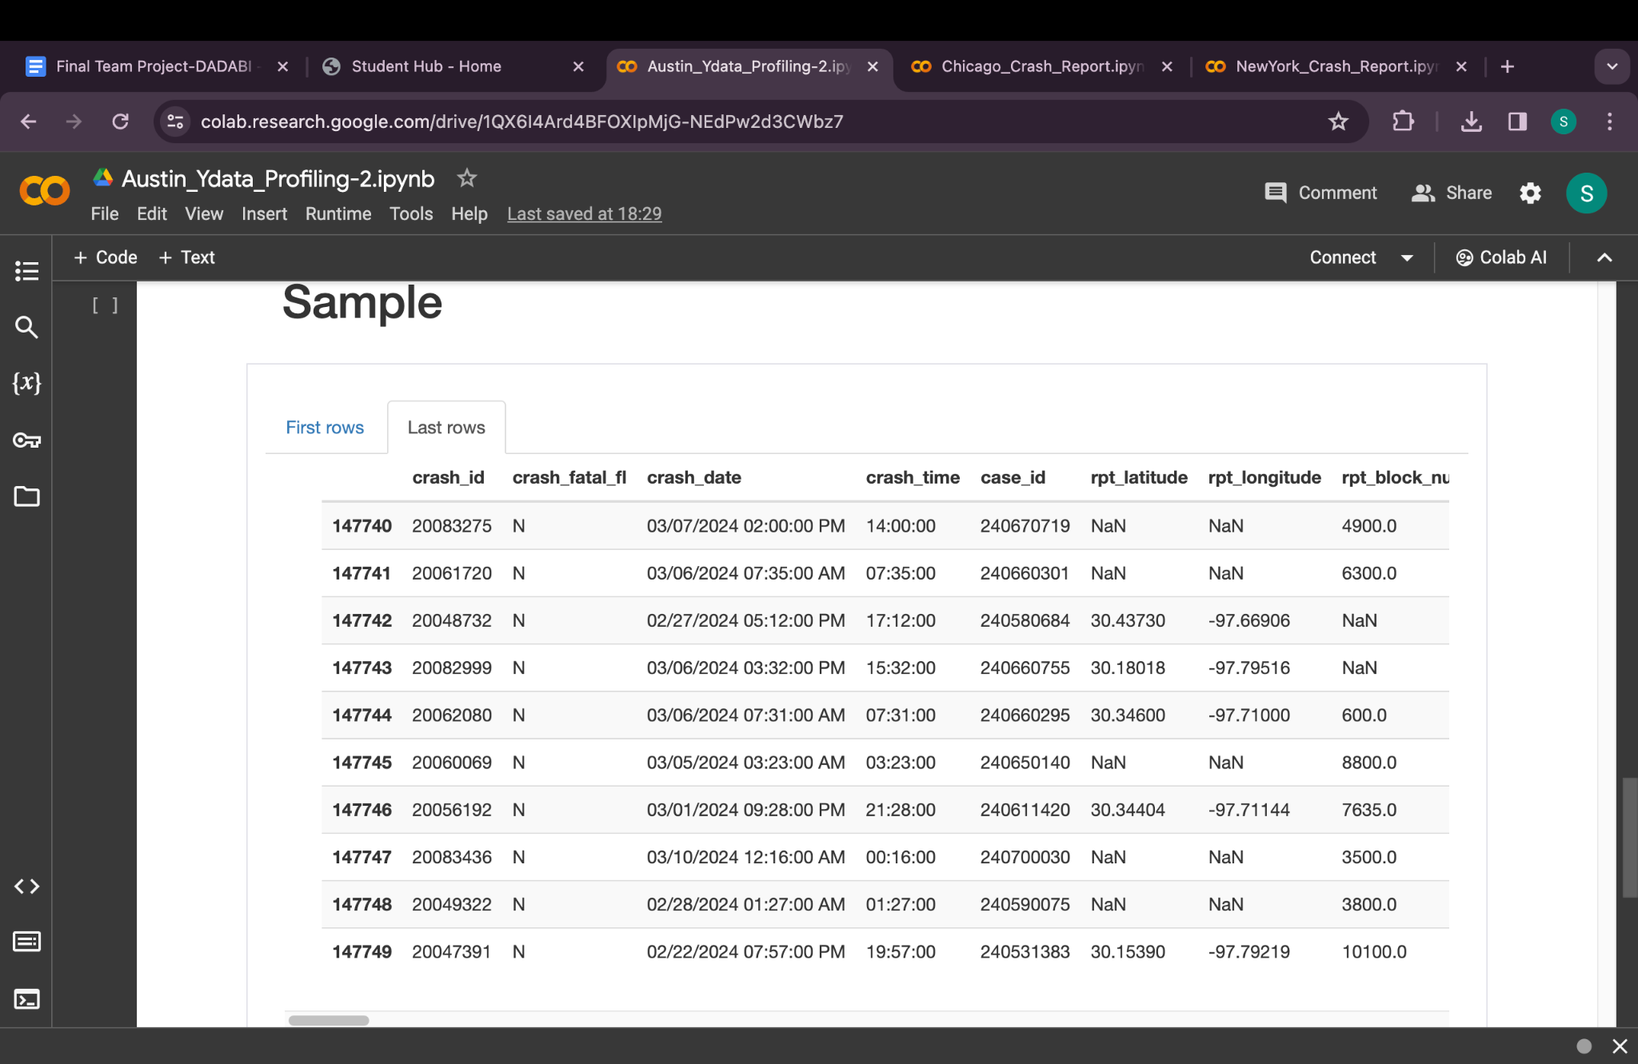

Data types:

1. **crash_fatal_fl**: **Boolean**
2. **crash_date**: **Date**
3. **crash_time**: **String** (Consider **TalendDate.ParseDate** for conversion if needed)
4. **case_id**: **String**
5. **rpt_latitude**: **Double**
6. **rpt_longitude**: **Double**
7. **rpt_block_num**: **String**
8. **rpt_street_pfx**: **String**
9. **rpt_street_name**: **String**
10. **rpt_street_sfx**: **String**
11. **crash_speed_limit**: **Integer**
12. **road_constr_zone_fl**: **Boolean**
13. **latitude**: **Double**
14. **longitude**: **Double**
15. **street_name**: **String**
16. **street_nbr**: **String** (Given the potential for alphanumeric values)
17. **street_name_2**: **String**
18. **street_nbr_2**: **String**
19. **crash_sev_id**: **Integer**
20. **sus_serious_injry_cnt**: **Integer**
21. **nonincap_injry_cnt**: **Integer**
22. **poss_injry_cnt**: **Integer**
23. **non_injry_cnt**: **Integer**
24. **unkn_injry_cnt**: **Integer**
25. **tot_injry_cnt**: **Integer**
26. **death_cnt**: **Integer**
27. **contrib_factr_p1_id**: **Integer** (or **String** if these are descriptive or categorical)
28. **contrib_factr_p2_id**: **Integer** (or **String** if these are descriptive or categorical)
29. **units_involved**: **String**
30. **atd_mode_category_metadata**: **String** (JSON strings can be parsed later if needed)
31. **pedestrian_fl**: **Boolean**
32. **motor_vehicle_fl**: **Boolean**
33. **motorcycle_fl**: **Boolean**
34. **bicycle_fl**: **Boolean**
35. **other_fl**: **Boolean**
36. **point**: **String** (Consider geospatial data type conversion based on DBMS)
37. **apd_confirmed_fatality**: **Boolean**
38. **apd_confirmed_death_count**: **Integer**
39. **motor_vehicle_death_count**: **Integer**
40. **motor_vehicle_serious_injury_count**: **Integer**
41. **bicycle_death_count**: **Integer**
42. **bicycle_serious_injury_count**: **Integer**
43. **pedestrian_death_count**: **Integer**
44. **pedestrian_serious_injury_count**: **Integer**
45. **motorcycle_death_count**: **Integer**
46. **motorcycle_serious_injury_count**: **Integer**
47. **other_death_count**: **Integer**
48. **other_serious_injury_count**: **Integer**
49. **onsys_fl**: **Boolean**
50. **private_dr_fl**: **Boolean**
51. **micromobility_serious_injury_count**: **Integer**
52. **micromobility_death_count**: **Integer**
53. **micromobility_fl**: **Boolean**
54. **crash_id**: **Long**

Austin Ydata Profiling

Dataset Overview: Likely contains weather data and traffic incident reports, including date, location, weather conditions, and number of incidents.

Missing Values: Weather datasets often have missing temperature or condition data; traffic reports might miss specific location details.

Statistical Summary: Would include temperature ranges, average number of incidents, and perhaps conditions leading to higher incident rates.

Data Distribution and Correlations: The distribution might show seasonal weather patterns, correlations between weather conditions and incidents.

Unique Values and Duplicates: Date and time could serve as unique identifiers, with a need to check for duplicate reports on incidents.

Ydata Profiling:

Report for Chicago:

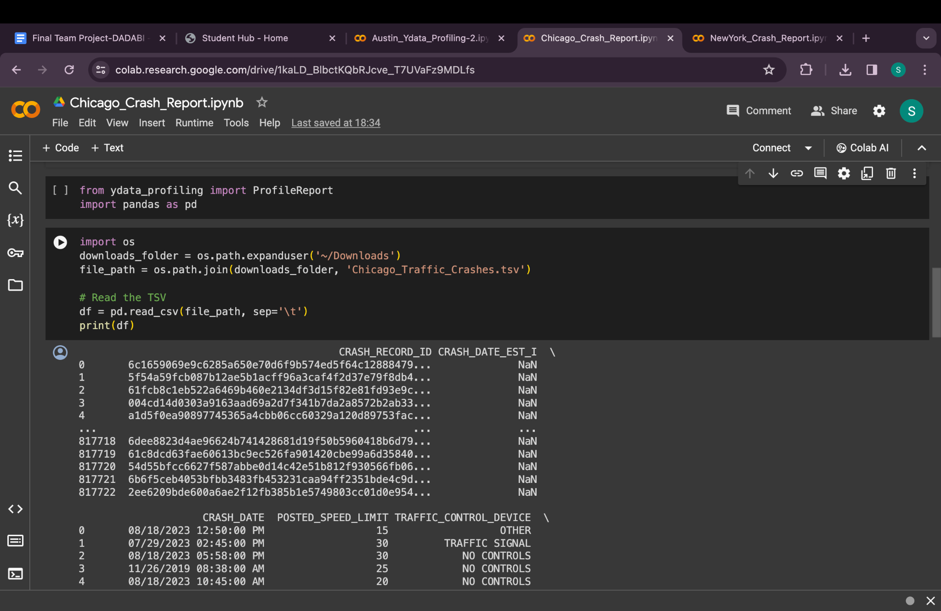

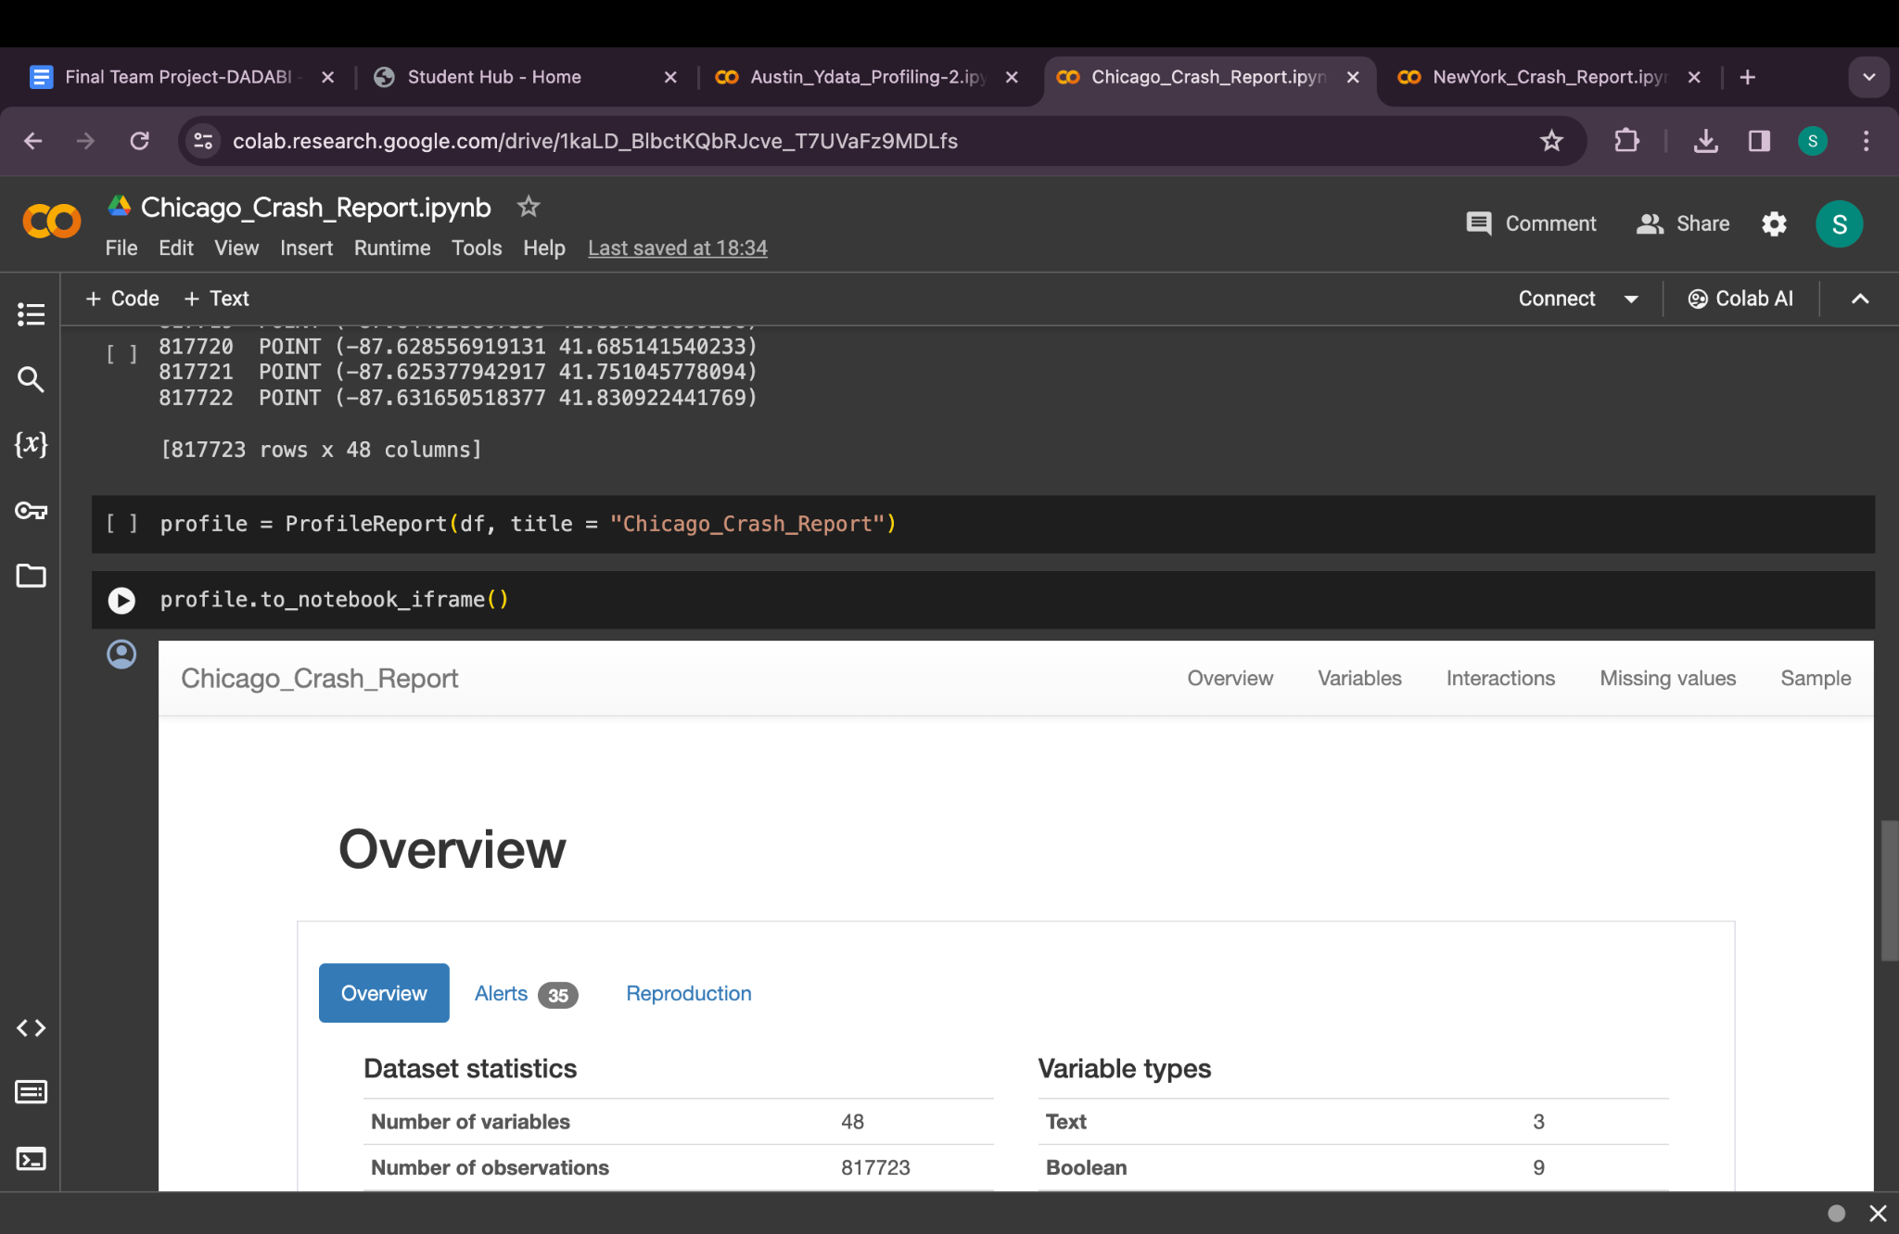

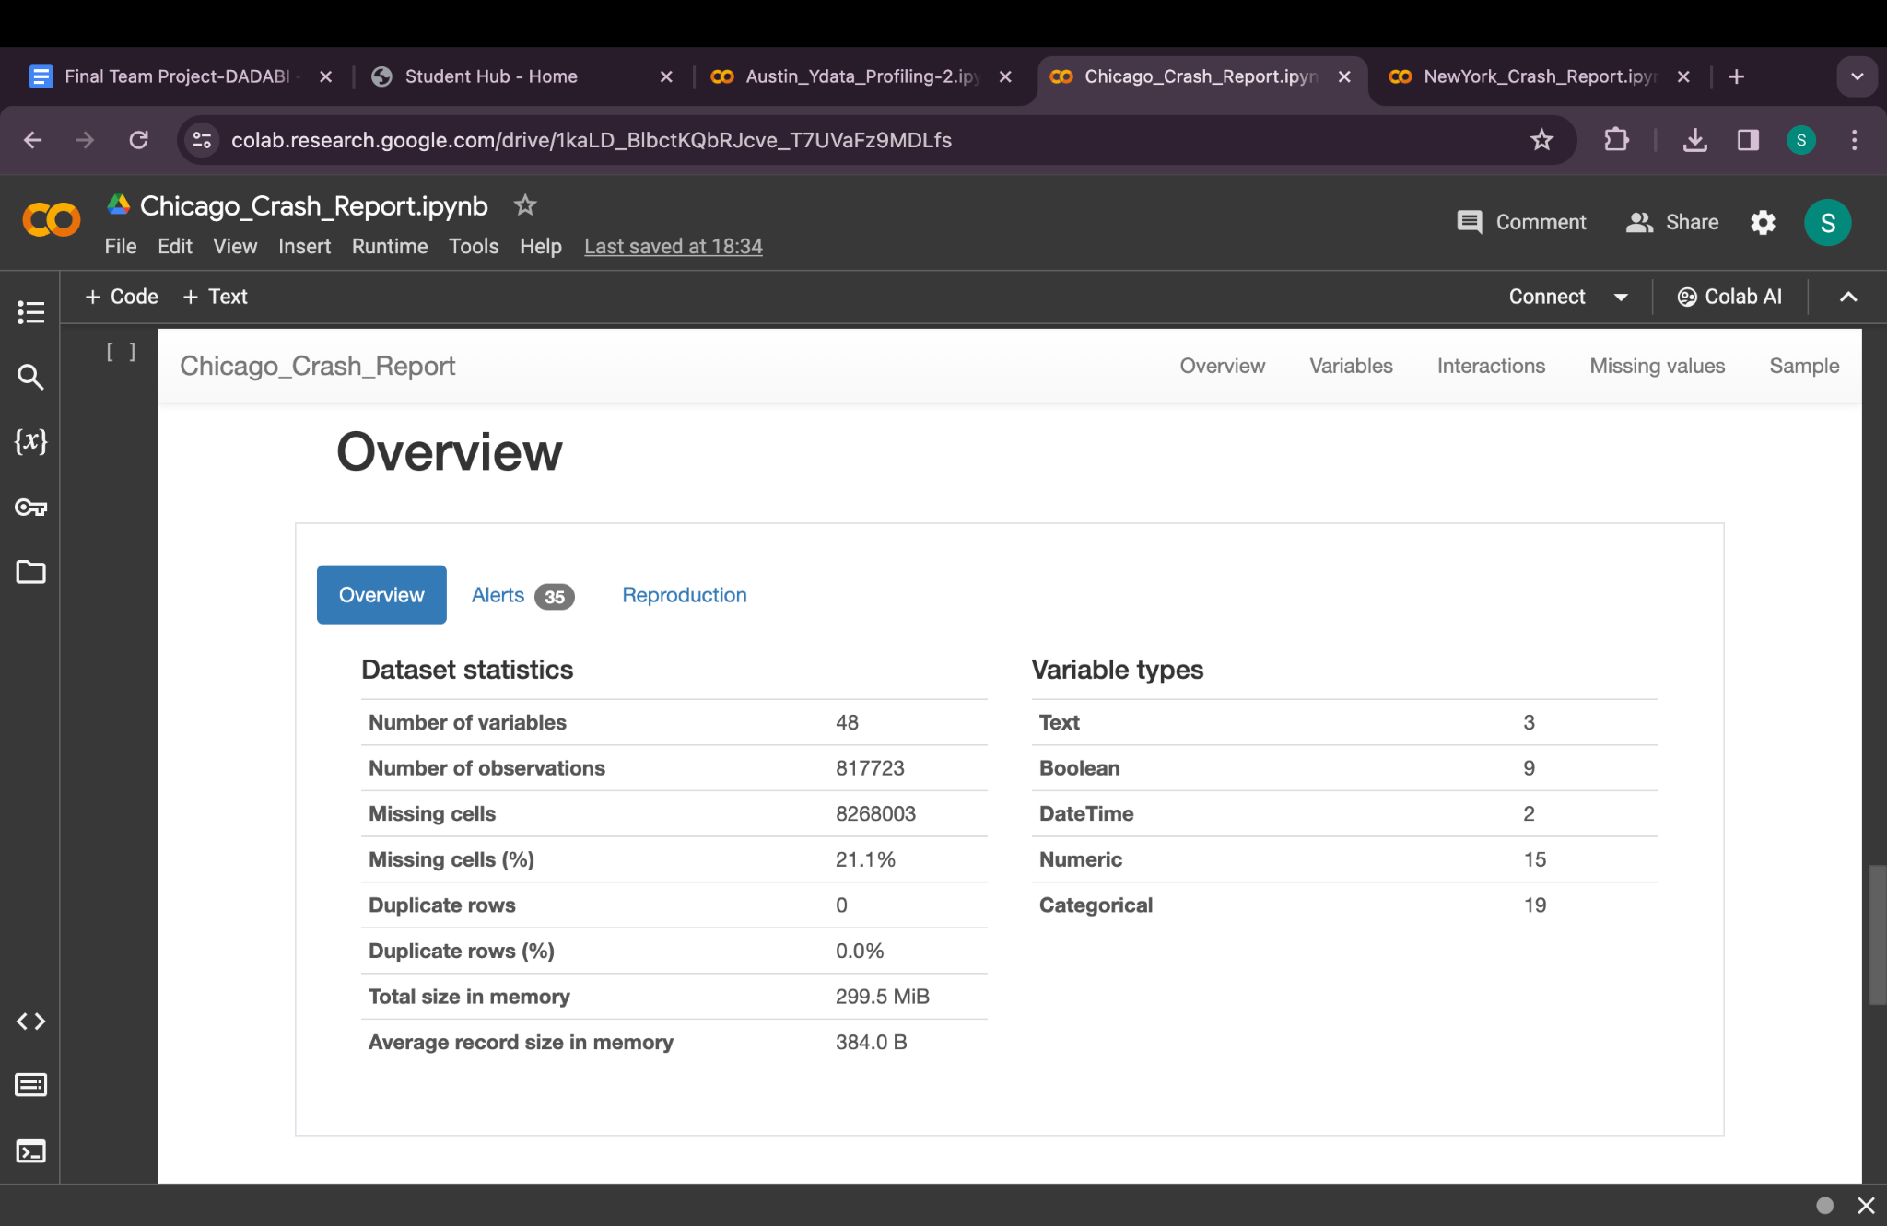

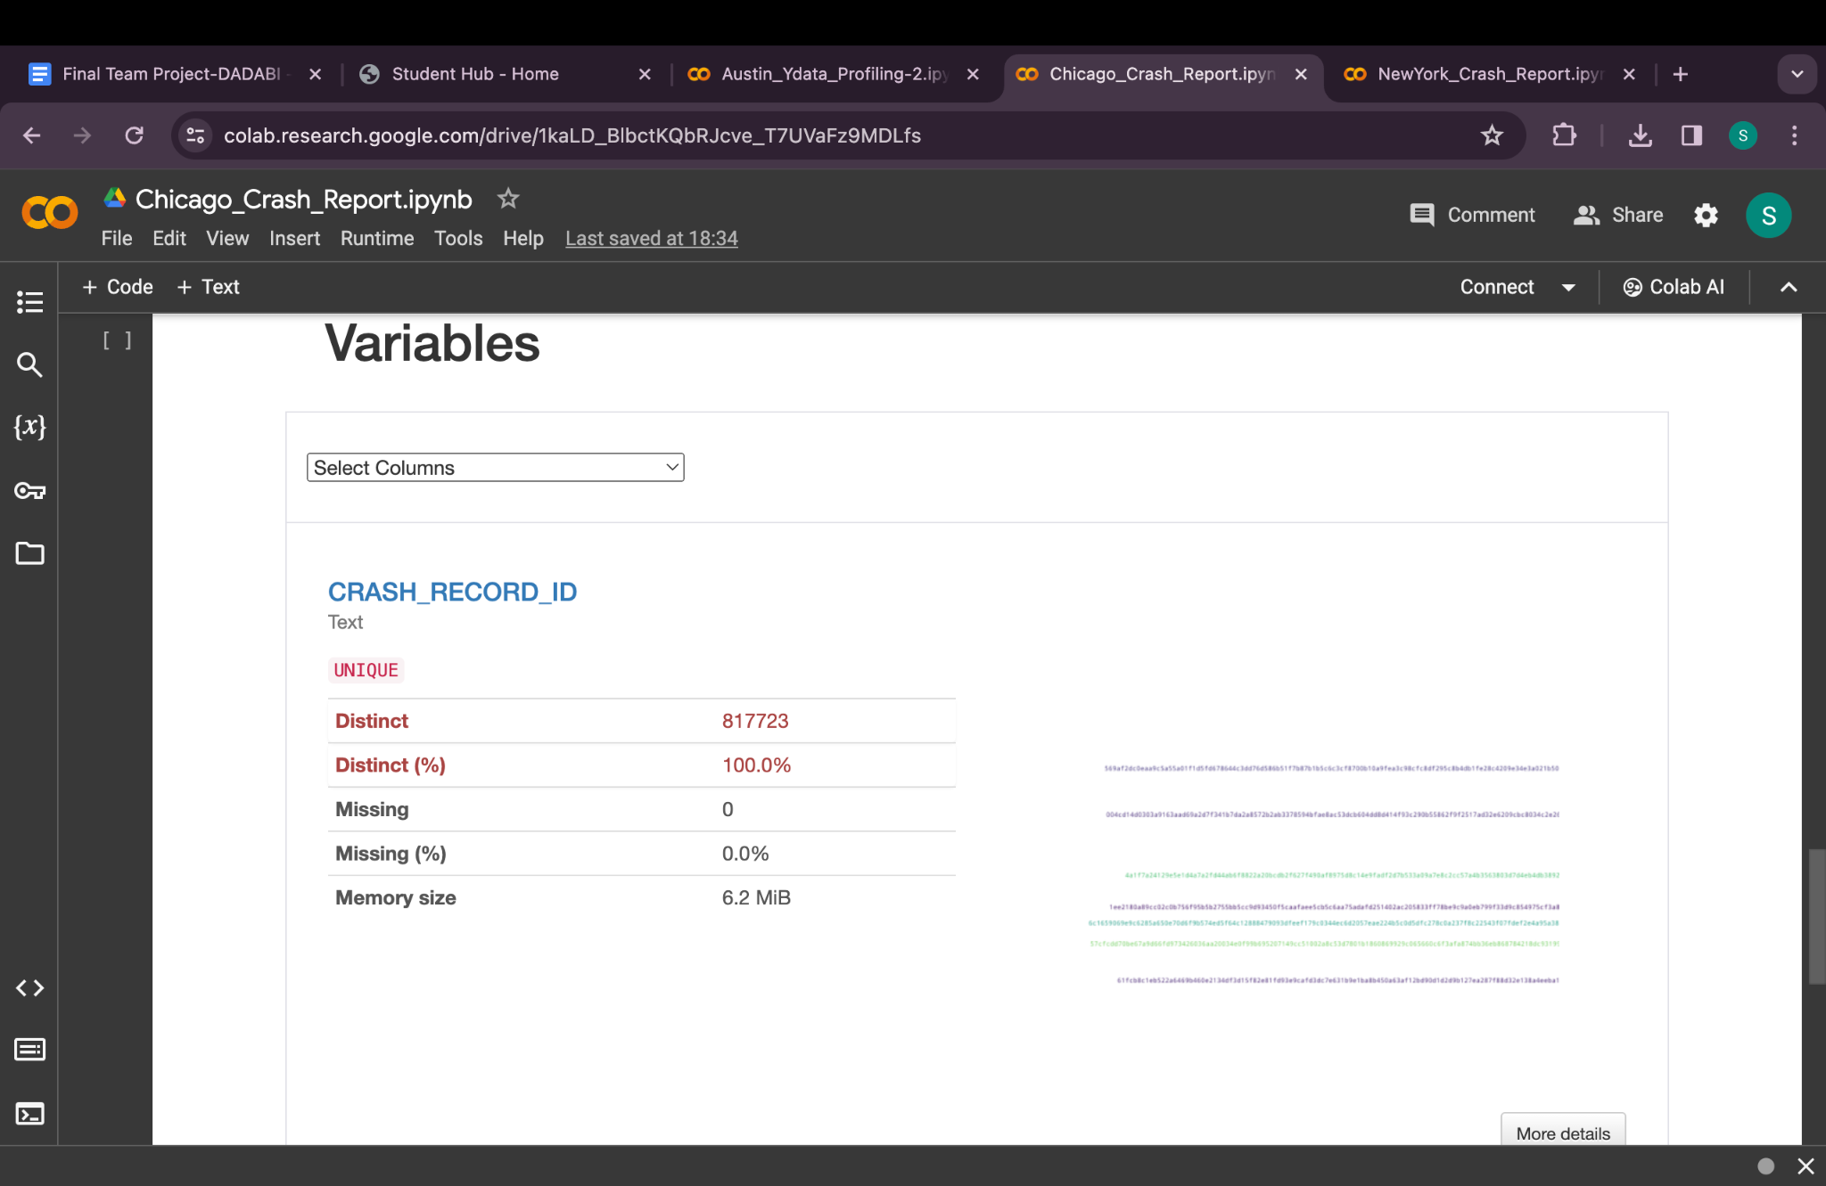

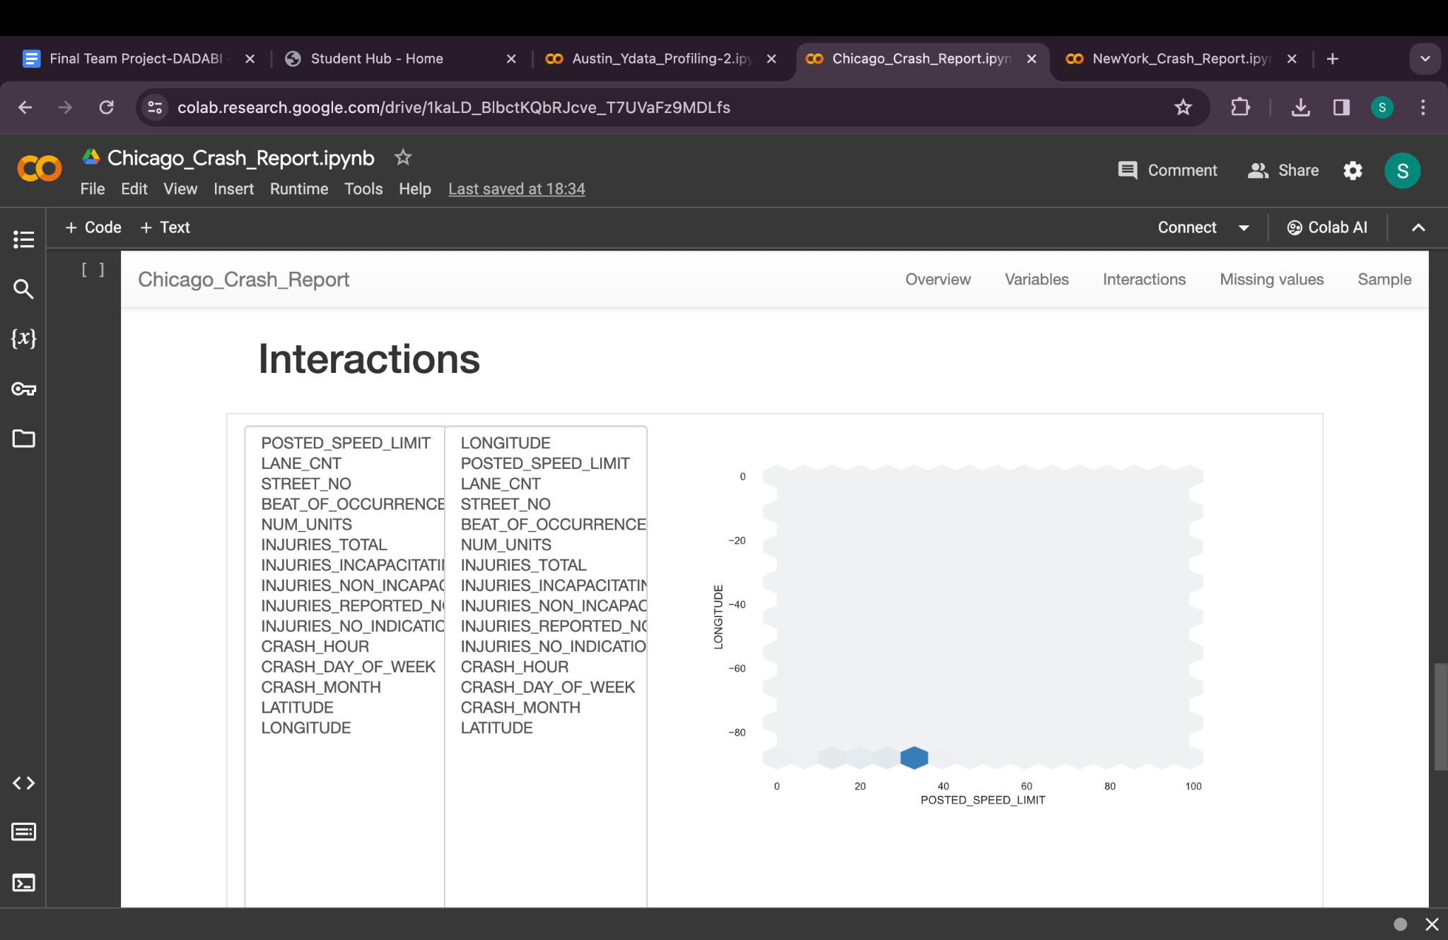

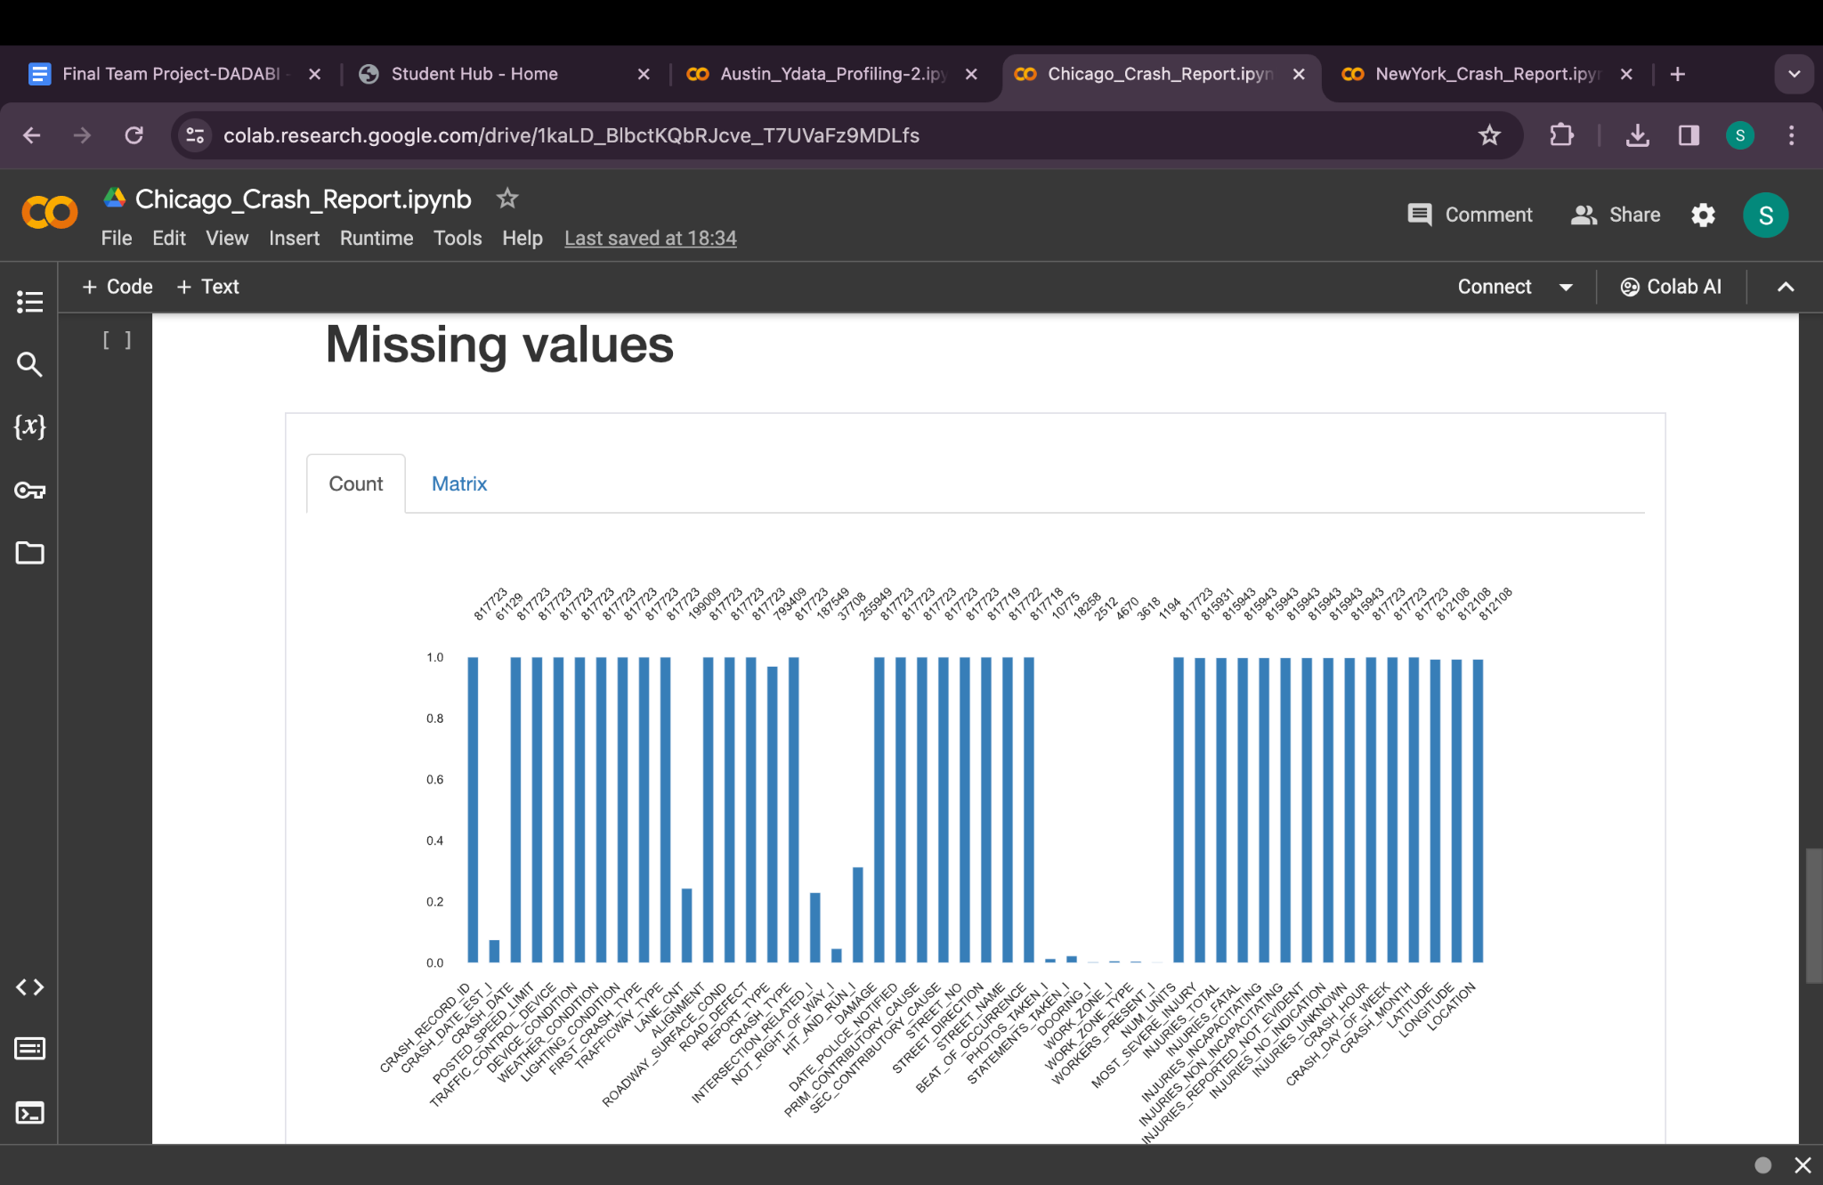

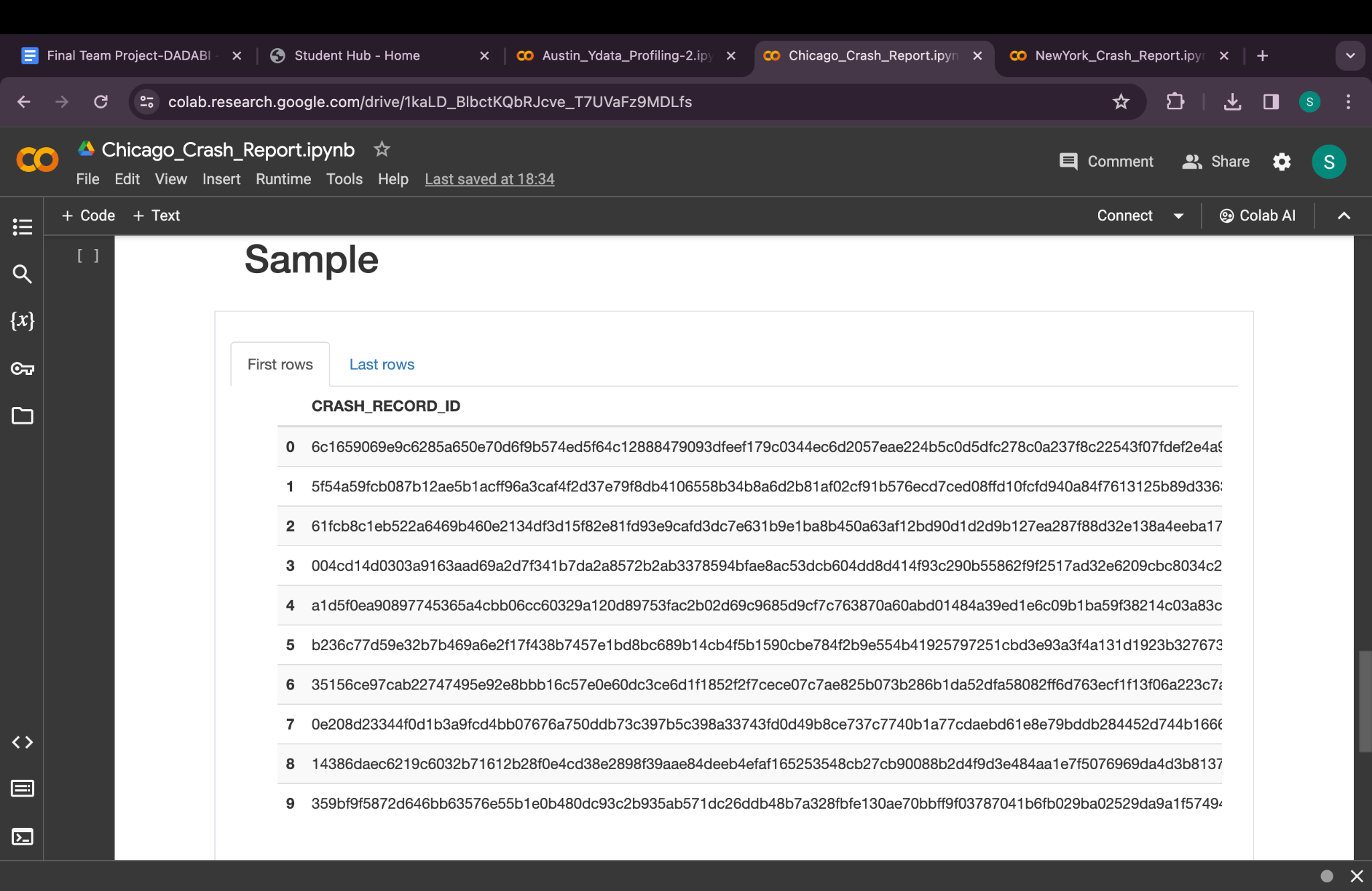

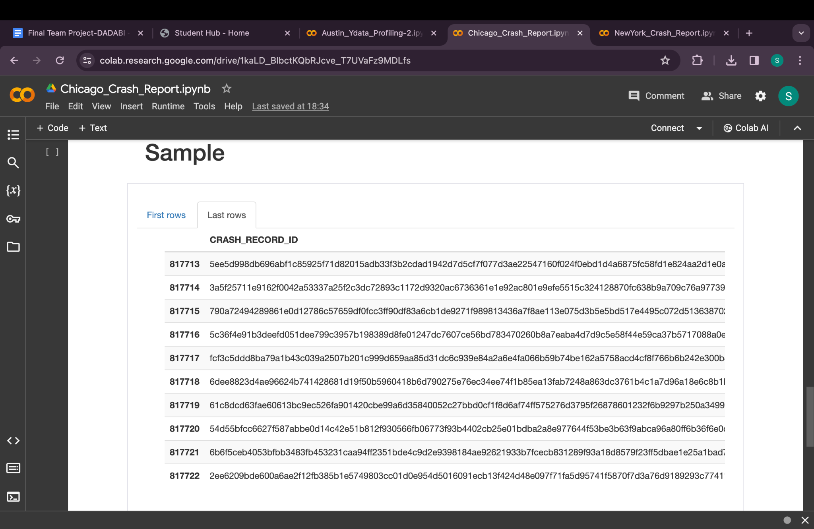

1. **CRASH_RECORD_ID**: **String**
2. **CRASH_DATE_EST_I**: **Boolean**
3. **CRASH_DATE**: **Date**
4. **POSTED_SPEED_LIMIT**: **Integer**
5. **TRAFFIC_CONTROL_DEVICE**: **String**
6. **DEVICE_CONDITION**: **String**
7. **WEATHER_CONDITION**: **String**
8. **LIGHTING_CONDITION**: **String**
9. **FIRST_CRASH_TYPE**: **String**
10. **TRAFFICWAY_TYPE**: **String**
11. **LANE_CNT**: **Double** (Given the possibility of fractional or large values and considering missing data)
12. **ALIGNMENT**: **String**
13. **ROADWAY_SURFACE_COND**: **String**
14. **ROAD_DEFECT**: **String**
15. **REPORT_TYPE**: **String**
16. **CRASH_TYPE**: **String**
17. **INTERSECTION_RELATED_I**: **Boolean**
18. **NOT_RIGHT_OF_WAY_I**: **Boolean**
19. **HIT_AND_RUN_I**: **Boolean**
20. **DAMAGE**: **String**
21. **DATE_POLICE_NOTIFIED**: **Date**
22. **PRIM_CONTRIBUTORY_CAUSE**: **String**
23. **SEC_CONTRIBUTORY_CAUSE**: **String**
24. **STREET_NO**: **Integer**
25. **STREET_DIRECTION**: **String**
26. **STREET_NAME**: **String**
27. **BEAT_OF_OCCURRENCE**: **Double** (Given the potential for large numbers, though **Integer** may suffice in most cases)
28. **PHOTOS_TAKEN_I**: **Boolean**
29. **STATEMENTS_TAKEN_I**: **Boolean**
30. **DOORING_I**: **Boolean**
31. **WORK_ZONE_I**: **Boolean**
32. **WORK_ZONE_TYPE**: **String**
33. **WORKERS_PRESENT_I**: **Boolean**
34. **NUM_UNITS**: **Integer**
35. **MOST_SEVERE_INJURY**: **String**
36. **INJURIES_TOTAL**: **Double** (Consider using **Integer** if values are whole numbers, but **Double** accommodates for any potential decimal values)
37. **INJURIES_FATAL**: **Double** (Same consideration as for INJURIES_TOTAL)
38. **INJURIES_INCAPACITATING**: **Double**
39. **INJURIES_NON_INCAPACITATING**: **Double**
40. **INJURIES_REPORTED_NOT_EVIDENT**: **Double**
41. **INJURIES_NO_INDICATION**: **Double**
42. **INJURIES_UNKNOWN**: **Integer** (Given it seems to be a constant or categorically limited field)
43. **CRASH_HOUR**: **Integer**
44. **CRASH_DAY_OF_WEEK**: **Integer**
45. **CRASH_MONTH**: **Integer**
46. **LATITUDE**: **Double**
47. **LONGITUDE**: **Double**
48. **LOCATION**: **String**

Chicago Crash Report

Dataset Overview: Similar to New York, with crash details in Chicago. Additional elements might include weather conditions, traffic flow data, and road conditions.

Missing Values: Similar gaps in data on specific crash details, witness statements, or exact conditions.

Statistical Summary: Would highlight frequent locations for crashes, impact of weather on crash rates, and perhaps the influence of road conditions.

Data Distribution and Correlations: Expectations include identifying peak times for crashes, seasonality effects, and potential correlations between road conditions and crash severity.

Unique Values and Duplicates: Ensuring each crash is uniquely reported is crucial, along with identifying any duplicate reports.

Ydata Profiling:

Report for New York:

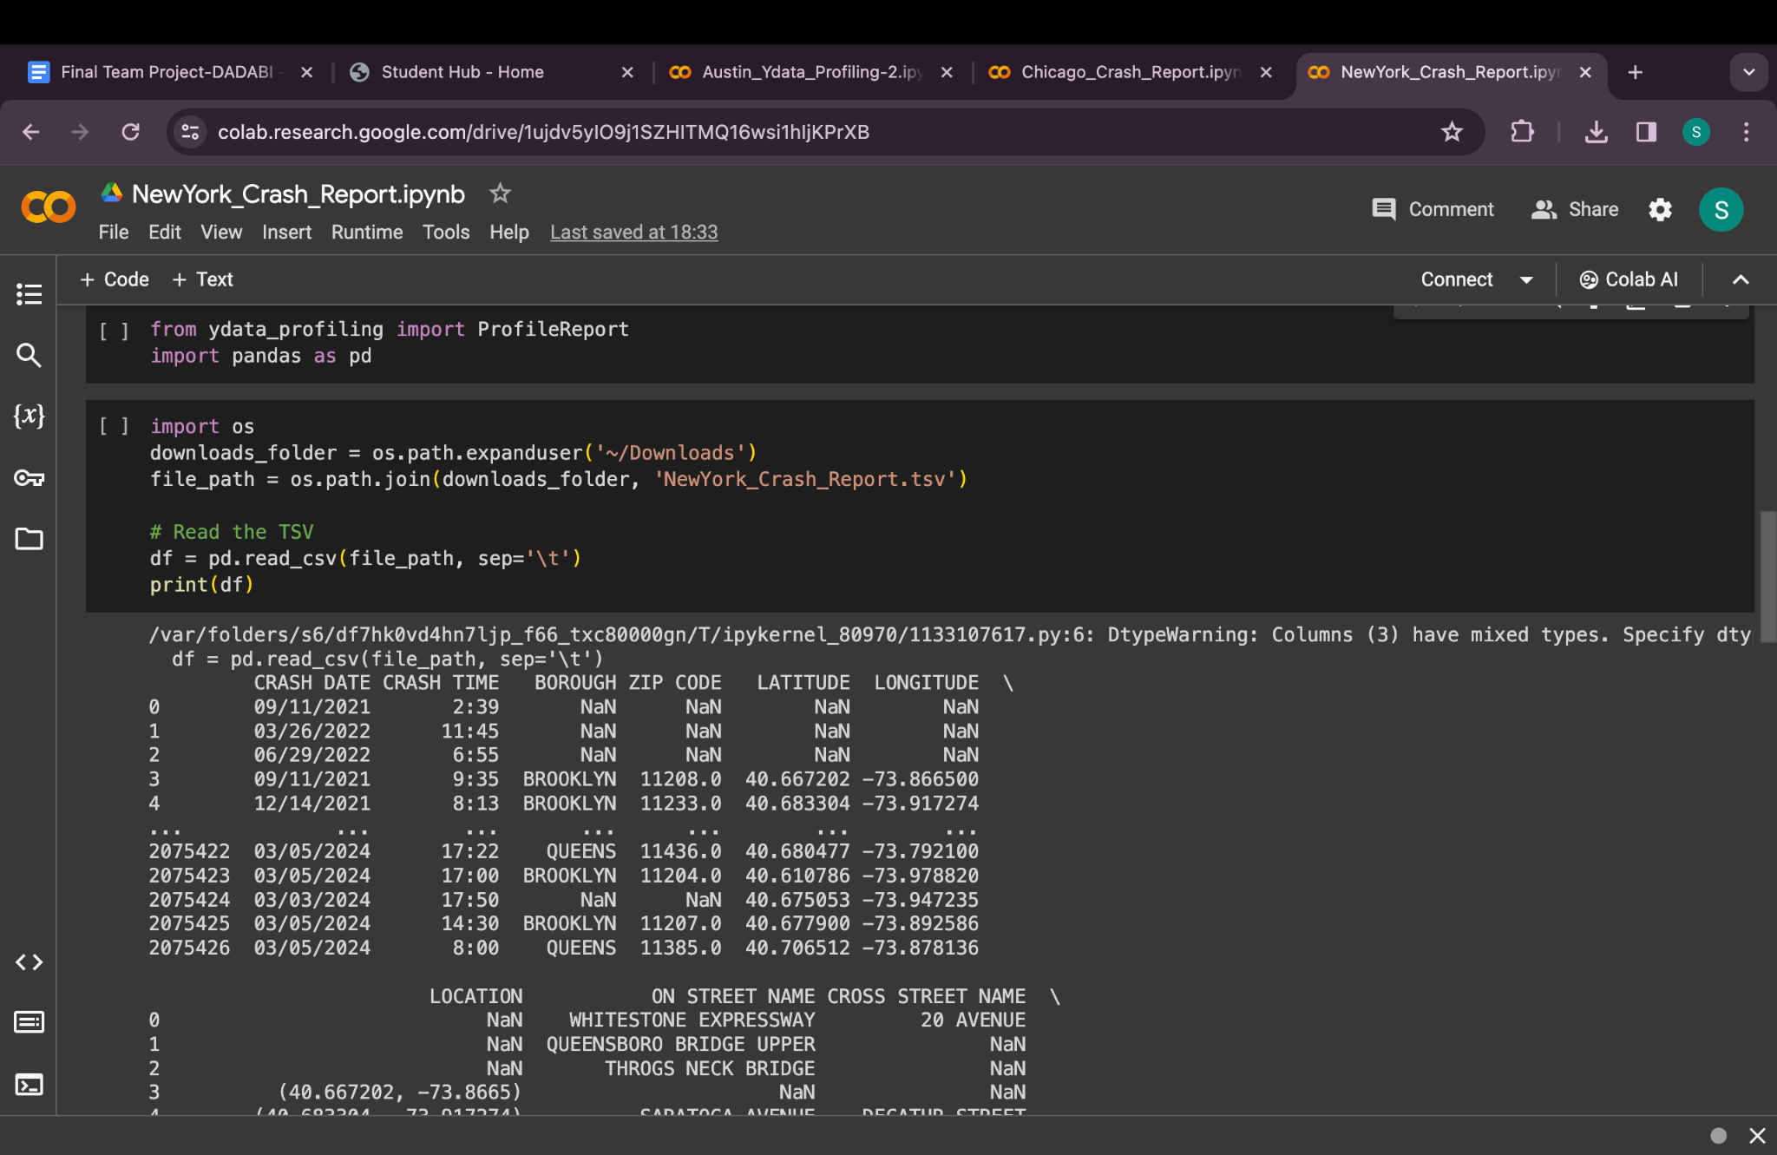

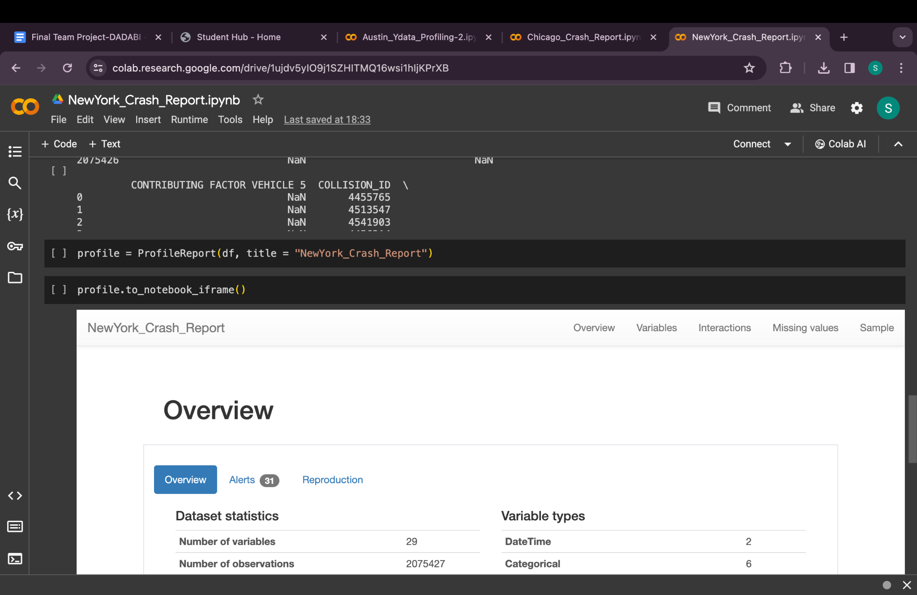

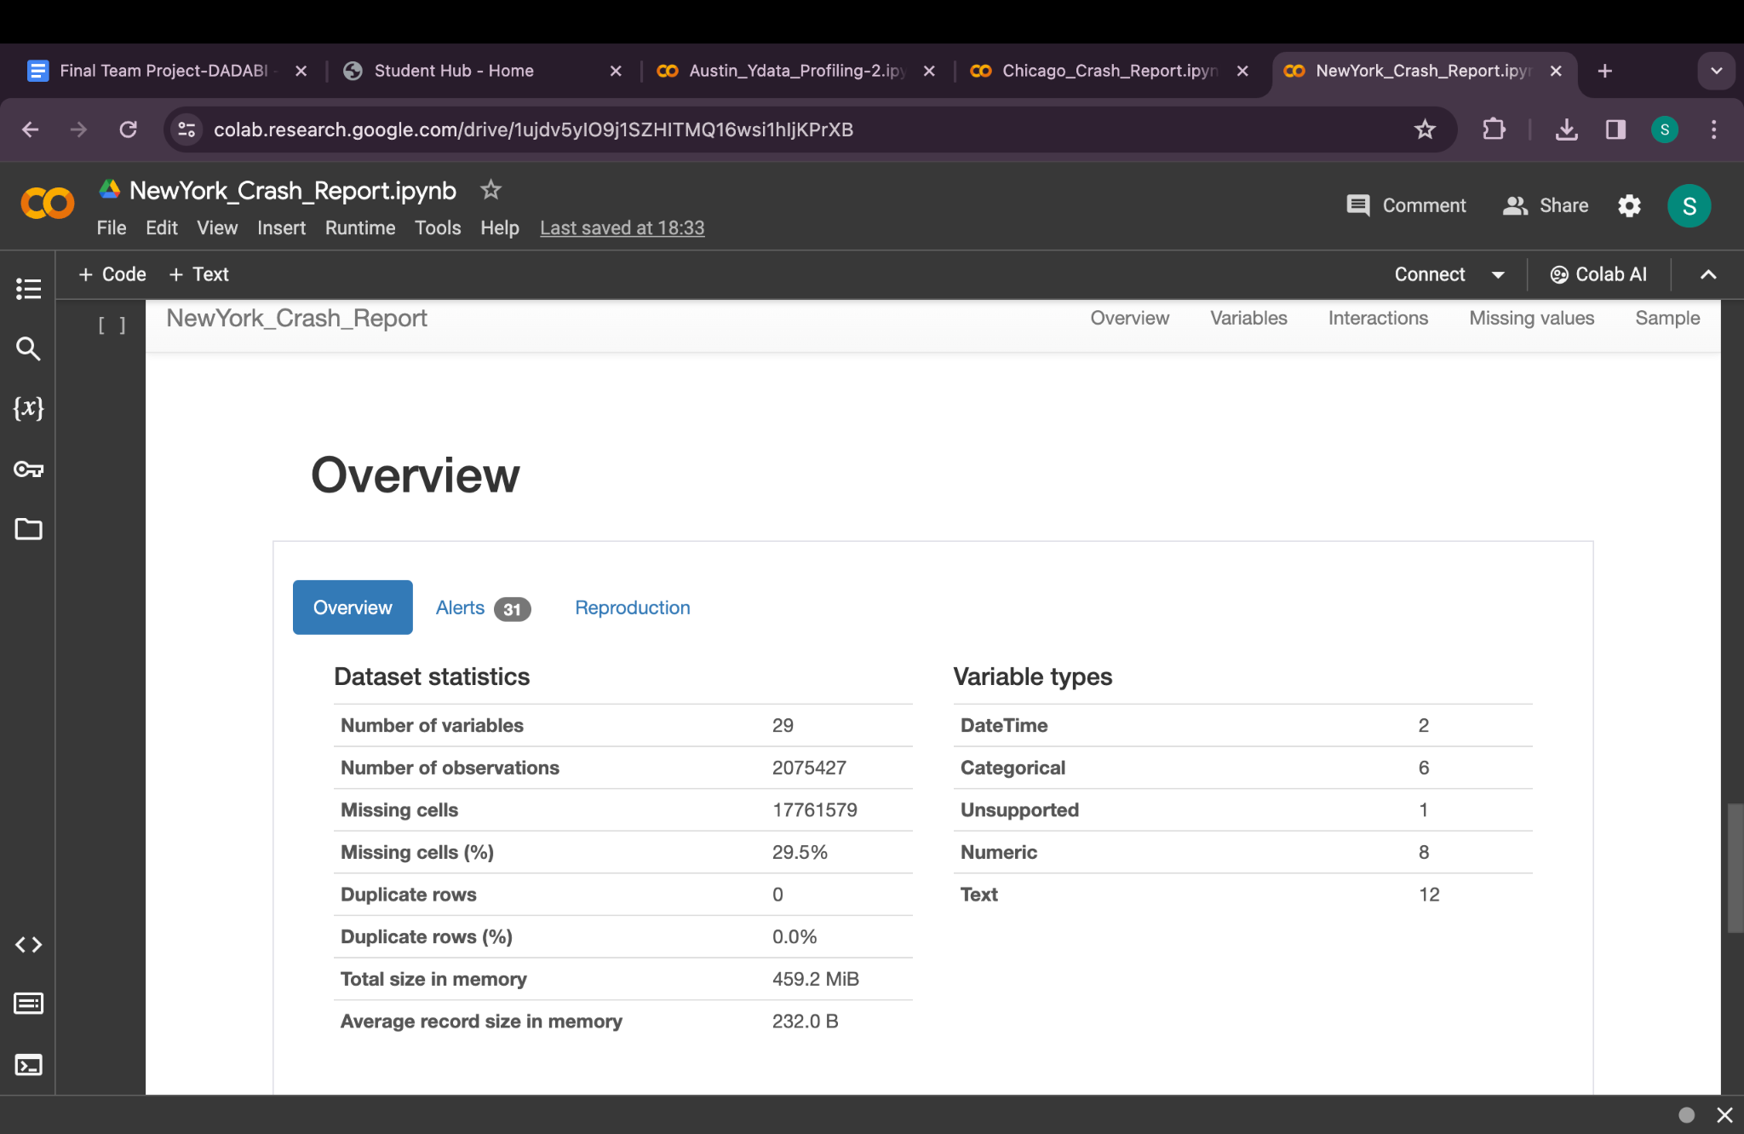

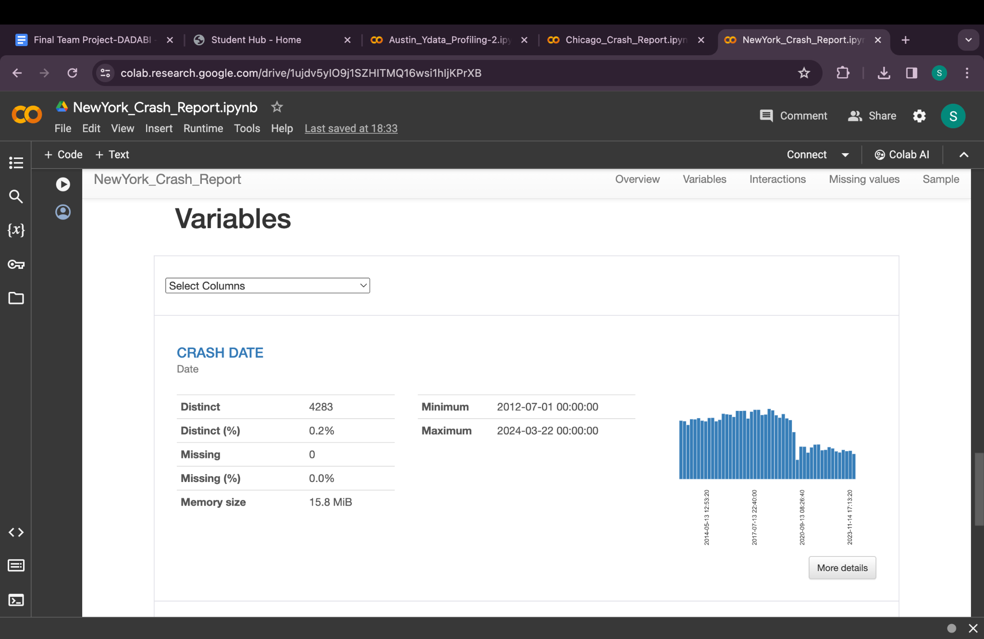

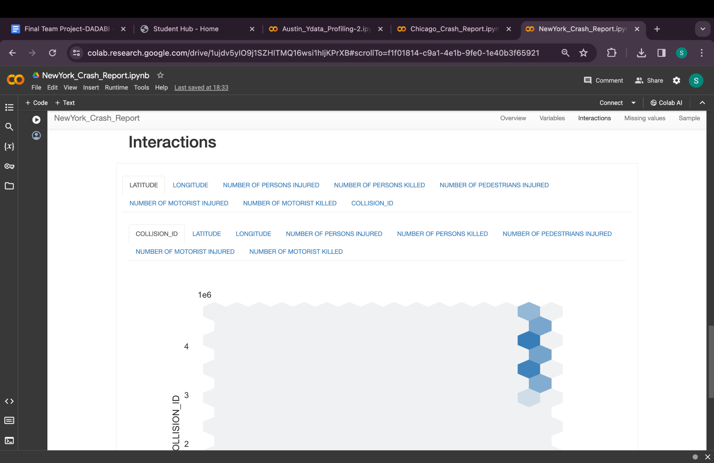

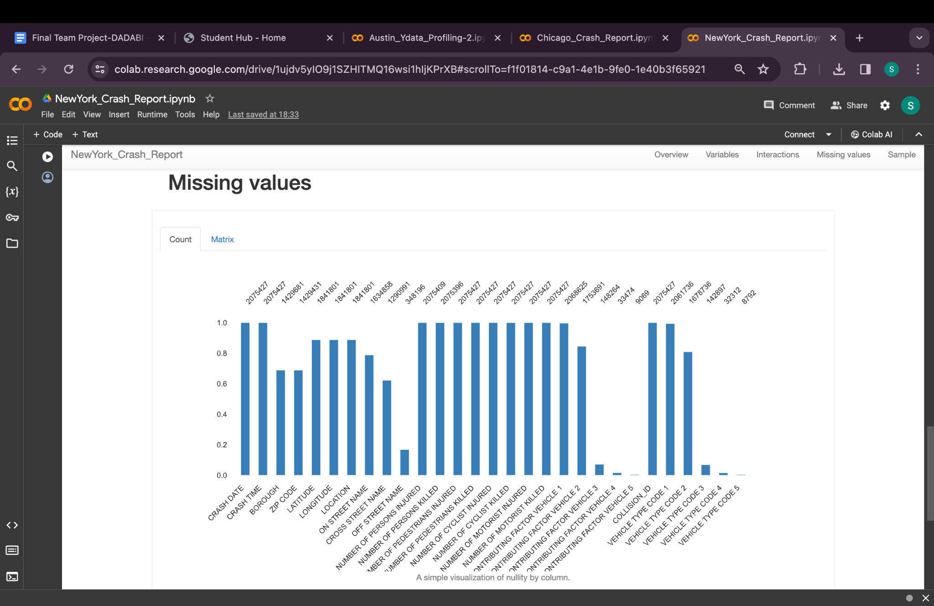

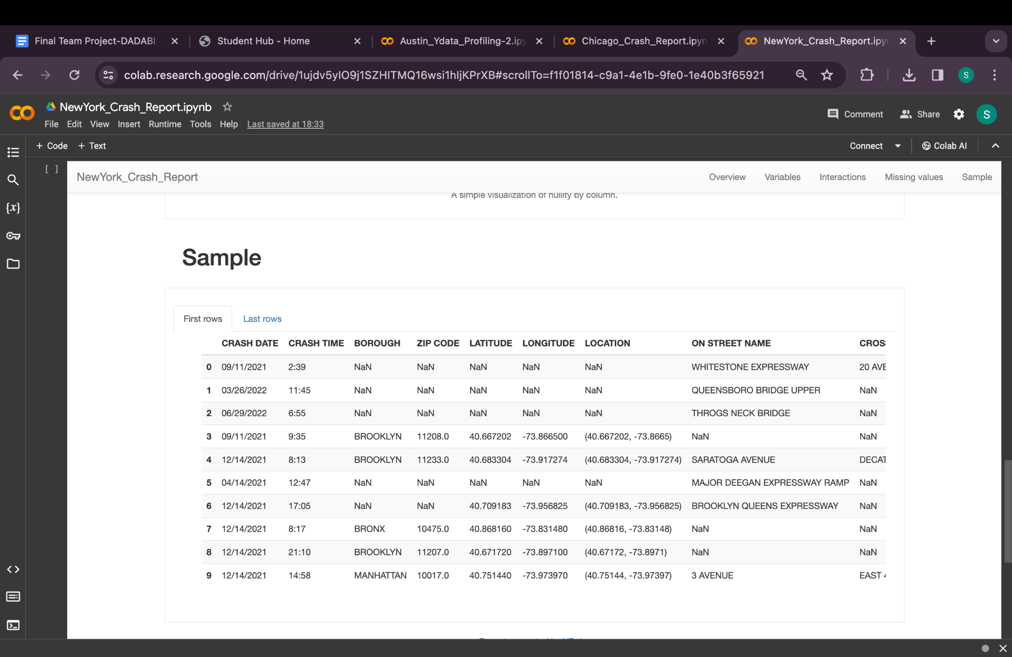

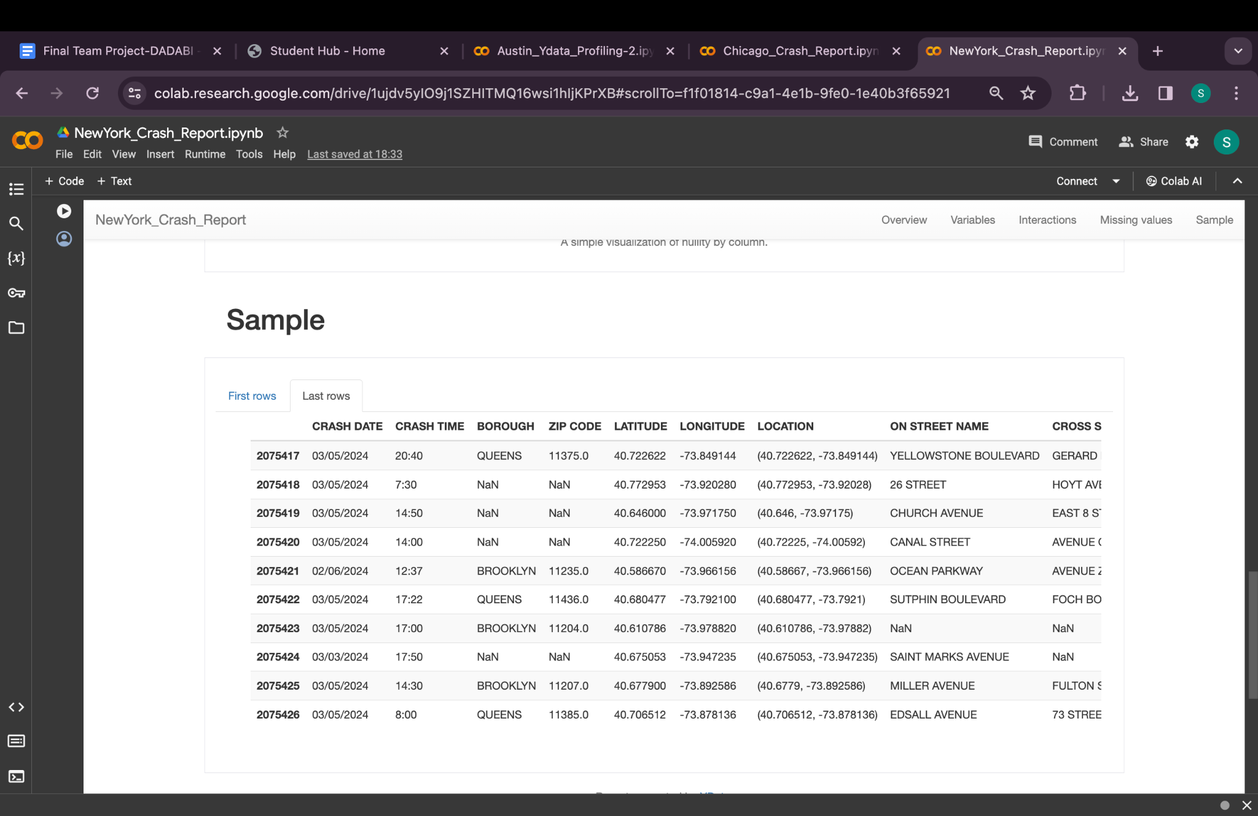

1. **CRASH DATE: Date**
2. **CRASH TIME: String (If time component only, otherwise consider using Date with appropriate formatting)**
3. **BOROUGH: String**
4. **ZIP CODE: String (To accommodate any formatting issues or mixed data types that led to it being unsupported)**
5. **LATITUDE: Double**
6. **LONGITUDE: Double**
7. **LOCATION: String (Could contain a textual representation of latitude and longitude)**
8. **ON STREET NAME: String**
9. **CROSS STREET NAME: String**
10. **OFF STREET NAME: String**
11. **NUMBER OF PERSONS INJURED: Integer**
12. **NUMBER OF PERSONS KILLED: Integer**
13. **NUMBER OF PEDESTRIANS INJURED: Integer**
14. **NUMBER OF PEDESTRIANS KILLED: Integer**
15. **NUMBER OF CYCLIST INJURED: Integer**
16. **NUMBER OF CYCLIST KILLED: Integer**
17. **NUMBER OF MOTORIST INJURED: Integer**
18. **NUMBER OF MOTORIST KILLED: Integer**
19. **CONTRIBUTING FACTOR VEHICLE 1: String**
20. **CONTRIBUTING FACTOR VEHICLE 2: String**
21. **CONTRIBUTING FACTOR VEHICLE 3: String (If applicable; otherwise, it might be null in the database)**
22. **CONTRIBUTING FACTOR VEHICLE 4: String (If applicable; otherwise, it might be null in the database)**
23. **CONTRIBUTING FACTOR VEHICLE 5: String (If applicable; otherwise, it might be null in the database)**
24. **COLLISION_ID: Long**
25. **VEHICLE TYPE CODE 1: String**
26. **VEHICLE TYPE CODE 2: String**
27. **VEHICLE TYPE CODE 3: String (If applicable; otherwise, it might be null in the database)**
28. **VEHICLE TYPE CODE 4: String (If applicable; otherwise, it might be null in the database)**
29. **VEHICLE TYPE CODE 5: String (If applicable; otherwise, it might be null in the database)**

New York Crash Report

Dataset Overview: Expected to have details on traffic crashes, including date, time, location, severity, and possibly involved parties or vehicle types.

Missing Values: Information on specific parties involved or exact locations might be incomplete.

Statistical Summary: Key stats would cover crash frequencies, times with higher incident rates, and common locations for crashes.

Data Distribution and Correlations: Analysis could reveal hotspots for incidents, time-of-day patterns, and correlations between vehicle types and crash severity.

Unique Values and Duplicates: Each report would ideally be unique, but the dataset should be checked for multiple entries for the same incident.

Designing dimensional model:

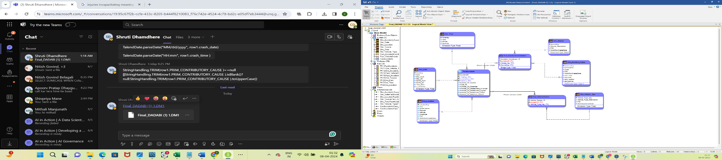

DDL SQL script:

/*

* TABLE: Dim_Accident_Cause

*/

CREATE TABLE Dim_Accident_Cause(

Cause_Key int NOT NULL,

Description varchar(500) NULL,

Code varchar(200) NULL,

PID varchar(10) NOT NULL,

WorkflowCreateDate date NOT NULL,

scd_start date NULL,

scd_end date NULL,

scd_version varchar(50) NULL,

scd_active varchar(100) NULL,

CONSTRAINT PK12 PRIMARY KEY NONCLUSTERED (Cause_Key)

)

go

IF OBJECT_ID('Dim_Accident_Cause') IS NOT NULL

PRINT '<<< CREATED TABLE Dim_Accident_Cause >>>'

ELSE

PRINT '<<< FAILED CREATING TABLE Dim_Accident_Cause >>>'

go

/*

* TABLE: Dim_Date

*/

CREATE TABLE Dim_Date(

DateKey int NOT NULL,

Date date NULL,

Day_Num int NOT NULL,

Day_Str varchar(100) NOT NULL,

Month_Num int NULL,

Month_Str varchar(100) NOT NULL,

Year_Num int NOT NULL,

is_weekend varchar(500) NULL,

CONSTRAINT PK3 PRIMARY KEY NONCLUSTERED (DateKey)

)

go

IF OBJECT_ID('Dim_Date') IS NOT NULL

PRINT '<<< CREATED TABLE Dim_Date >>>'

ELSE

PRINT '<<< FAILED CREATING TABLE Dim_Date >>>'

go

/*

* TABLE: Dim_Location

*/

CREATE TABLE Dim_Location(

LocationKey int NOT NULL,

City varchar(10) NULL,

[Street Name] varchar(5000) NULL,

Zipcode varchar(10) NULL,

Latitute varchar(23) NULL,

Longitude varchar(23) NULL,

PID varchar(10) NOT NULL,

WorkflowCreateDate date NULL,

CONSTRAINT PK8 PRIMARY KEY NONCLUSTERED (LocationKey)

)

go

IF OBJECT_ID('Dim_Location') IS NOT NULL

PRINT '<<< CREATED TABLE Dim_Location >>>'

ELSE

PRINT '<<< FAILED CREATING TABLE Dim_Location >>>'

go

/*

* TABLE: Dim_Source

*/

CREATE TABLE Dim_Source(

SourceKey int NOT NULL,

Source_Description varchar(10) NULL,

PID varchar(20) NOT NULL,

WorkflowCreateDate date NOT NULL,

CONSTRAINT PK16 PRIMARY KEY NONCLUSTERED (SourceKey)

)

go

IF OBJECT_ID('Dim_Source') IS NOT NULL

PRINT '<<< CREATED TABLE Dim_Source >>>'

ELSE

PRINT '<<< FAILED CREATING TABLE Dim_Source >>>'

go

/*

* TABLE: Dim_Time

*/

CREATE TABLE Dim_Time(

TimeKey int NOT NULL,

Hour int NULL,

Minute int NULL,

Seconds int NULL,

CONSTRAINT PK7 PRIMARY KEY NONCLUSTERED (TimeKey)

)

go

IF OBJECT_ID('Dim_Time') IS NOT NULL

PRINT '<<< CREATED TABLE Dim_Time >>>'

ELSE

PRINT '<<< FAILED CREATING TABLE Dim_Time >>>'

go

/*

* TABLE: Dim_Vehicle_Type

*/

CREATE TABLE Dim_Vehicle_Type(

Vehicle_Type_Key int NOT NULL,

Vehicle_Type_Description varchar(10000) NULL,

PID varchar(20) NOT NULL,

WorkflowCreateDate date NULL,

CONSTRAINT PK11 PRIMARY KEY NONCLUSTERED (Vehicle_Type_Key)

)

go

IF OBJECT_ID('Dim_Vehicle_Type') IS NOT NULL

PRINT '<<< CREATED TABLE Dim_Vehicle_Type >>>'

ELSE

PRINT '<<< FAILED CREATING TABLE Dim_Vehicle_Type >>>'

go

/*

* TABLE: Fact_AccidentContributors

*/

CREATE TABLE Fact_AccidentContributors(

Accident_Contributor_ID int NOT NULL,

AccidentID int NOT NULL,

Cause_Key int NOT NULL,

SourceKey int NOT NULL,

CONSTRAINT PK15 PRIMARY KEY NONCLUSTERED (Accident_Contributor_ID, AccidentID)

)

go

IF OBJECT_ID('Fact_AccidentContributors') IS NOT NULL

PRINT '<<< CREATED TABLE Fact_AccidentContributors >>>'

ELSE

PRINT '<<< FAILED CREATING TABLE Fact_AccidentContributors >>>'

go

/*

* TABLE: Fact_VehicleDetails

*/

CREATE TABLE Fact_VehicleDetails(

Vehicle_Details_ID int NOT NULL,

AccidentID int NOT NULL,

Vehicle_Type_Key int NOT NULL,

Is_Involved_in_Multi_Vehicle_Incident int NULL,

CONSTRAINT PK14 PRIMARY KEY NONCLUSTERED (Vehicle_Details_ID, AccidentID)

)

go

IF OBJECT_ID('Fact_VehicleDetails') IS NOT NULL

PRINT '<<< CREATED TABLE Fact_VehicleDetails >>>'

ELSE

PRINT '<<< FAILED CREATING TABLE Fact_VehicleDetails >>>'

go

/*

* TABLE: FactAccidents

*/

CREATE TABLE FactAccidents(

AccidentID int NOT NULL,

TimeKey int NOT NULL,

LocationKey int NOT NULL,

DateKey int NOT NULL,

Number_Of_Injuries int NULL,

Crash_ID varchar(500) NOT NULL,

Number_Of_Fatalities int NULL,

Number_Of_Pedestrians_Involved int NULL,

Number_Of_Pedestrians_Injured int NULL,

Number_Of_Pedestrians_Killed int NULL,

Number_Of_Motorists_Injured int NULL,

Number_Of_Motorists_Killed int NULL,

Number_Of_Cyclists_Injured int NULL,

Number_Of_Cyclists_Killed int NULL,

CONSTRAINT PK1 PRIMARY KEY NONCLUSTERED (AccidentID)

)

go

IF OBJECT_ID('FactAccidents') IS NOT NULL

PRINT '<<< CREATED TABLE FactAccidents >>>'

ELSE

PRINT '<<< FAILED CREATING TABLE FactAccidents >>>'

go

/*

* TABLE: Fact_AccidentContributors

*/

ALTER TABLE Fact_AccidentContributors ADD CONSTRAINT RefDim_Accident_Cause12

FOREIGN KEY (Cause_Key)

REFERENCES Dim_Accident_Cause(Cause_Key)

go

ALTER TABLE Fact_AccidentContributors ADD CONSTRAINT RefDim_Source17

FOREIGN KEY (SourceKey)

REFERENCES Dim_Source(SourceKey)

go

ALTER TABLE Fact_AccidentContributors ADD CONSTRAINT RefFactAccidents24

FOREIGN KEY (AccidentID)

REFERENCES FactAccidents(AccidentID)

go

/*

* TABLE: Fact_VehicleDetails

*/

ALTER TABLE Fact_VehicleDetails ADD CONSTRAINT RefDim_Vehicle_Type11

FOREIGN KEY (Vehicle_Type_Key)

REFERENCES Dim_Vehicle_Type(Vehicle_Type_Key)

go

ALTER TABLE Fact_VehicleDetails ADD CONSTRAINT RefFactAccidents25

FOREIGN KEY (AccidentID)

REFERENCES FactAccidents(AccidentID)

go

/*

* TABLE: FactAccidents

*/

ALTER TABLE FactAccidents ADD CONSTRAINT RefDim_Location8

FOREIGN KEY (LocationKey)

REFERENCES Dim_Location(LocationKey)

go

ALTER TABLE FactAccidents ADD CONSTRAINT RefDim_Time9

FOREIGN KEY (TimeKey)

REFERENCES Dim_Time(TimeKey)

go

ALTER TABLE FactAccidents ADD CONSTRAINT RefDim_Date10

FOREIGN KEY (DateKey)

REFERENCES Dim_Date(DateKey)

go

Staging using Talend:

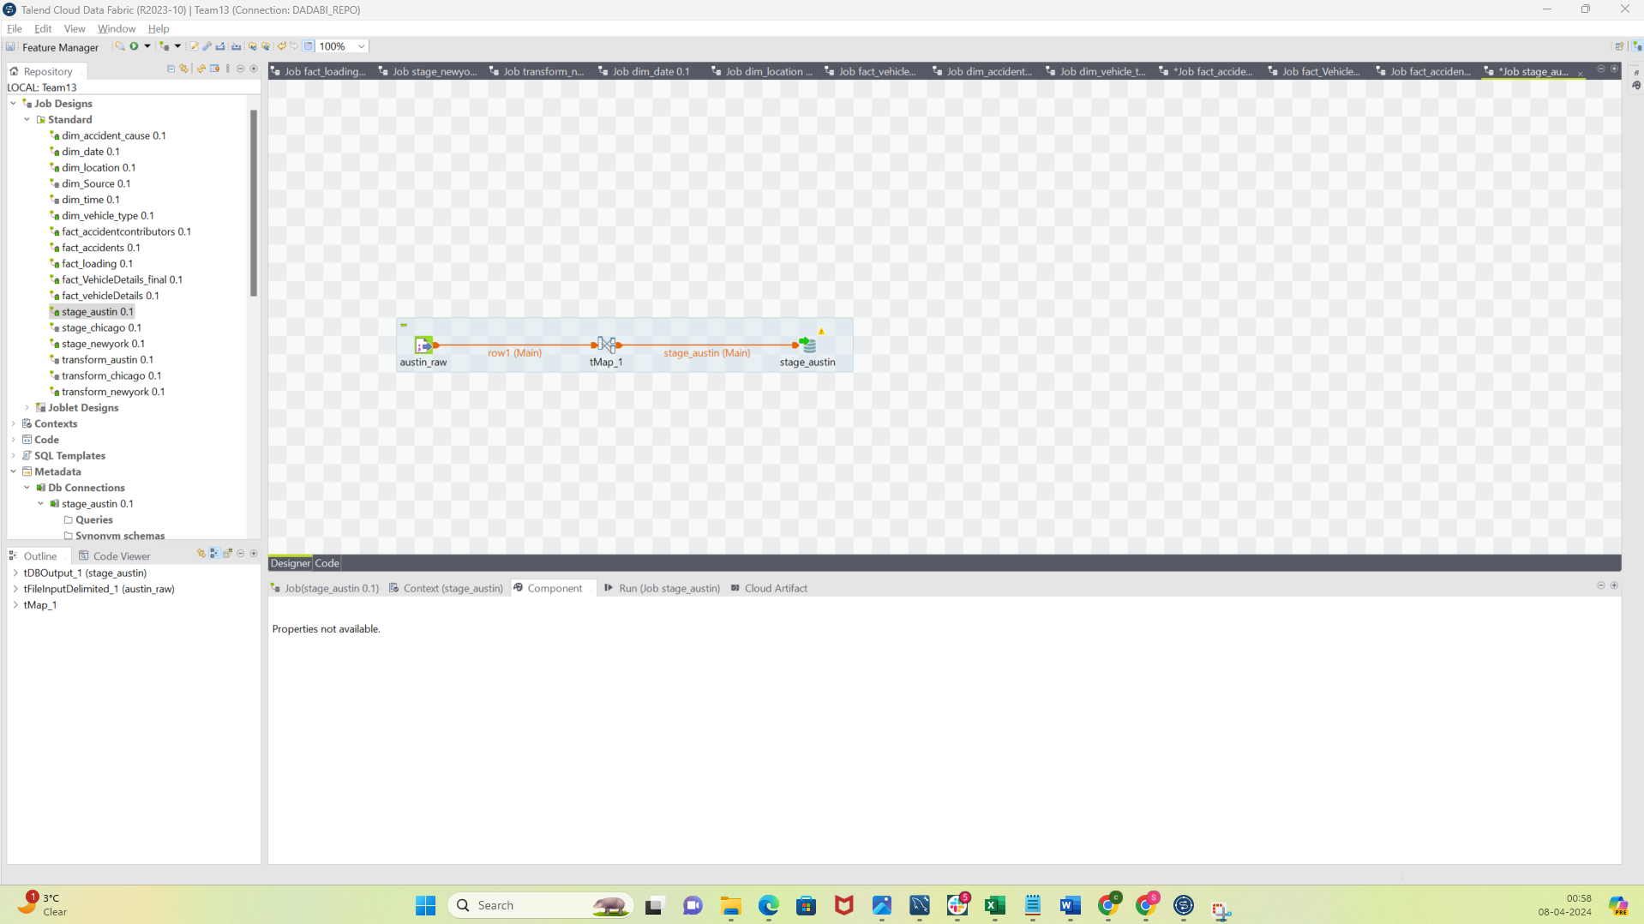

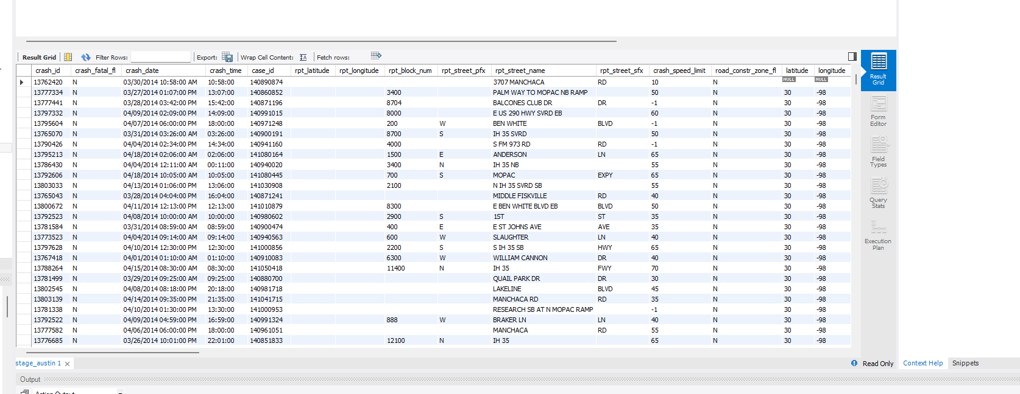

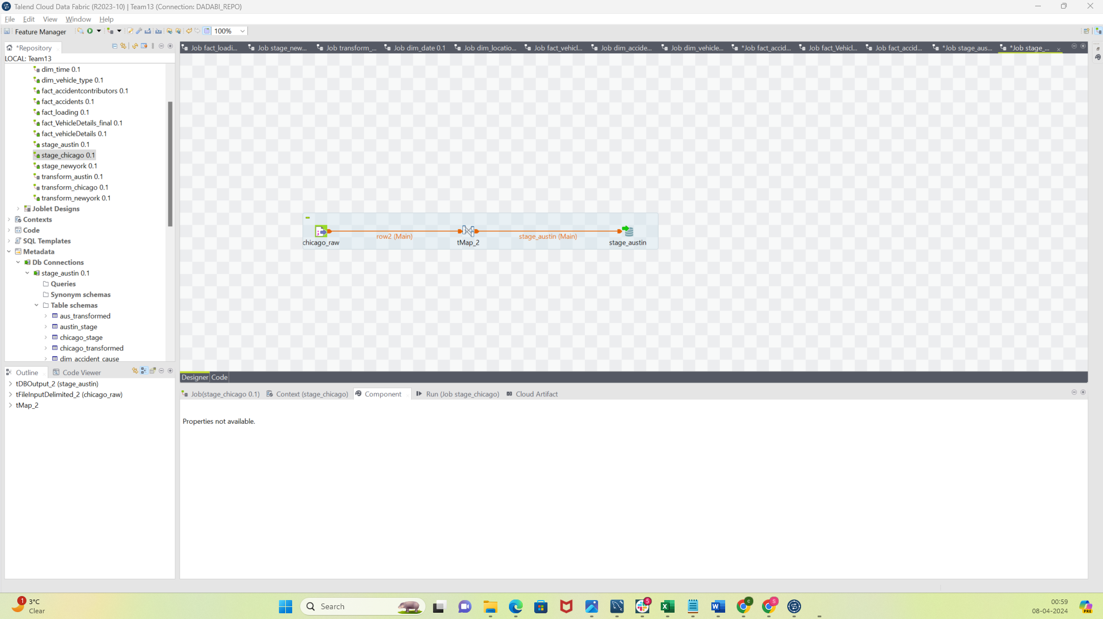

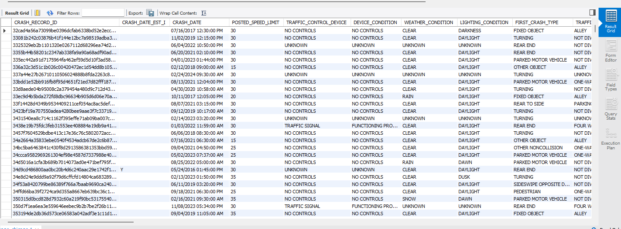

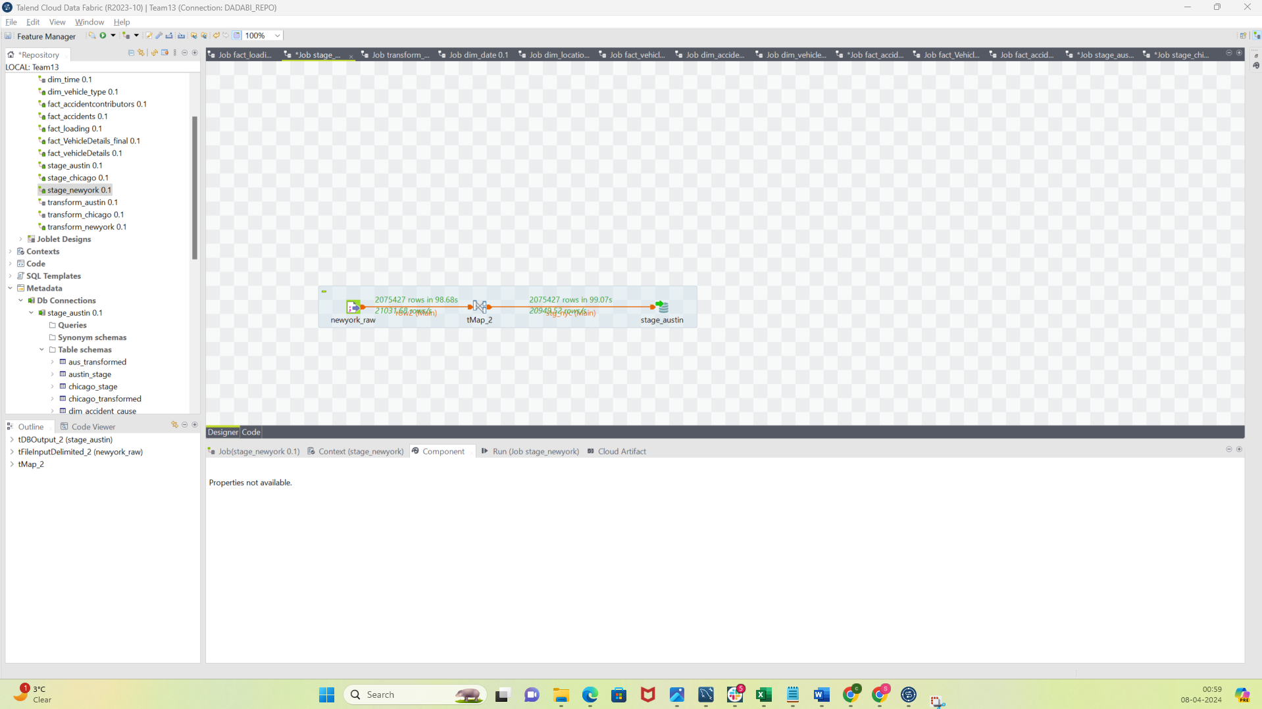

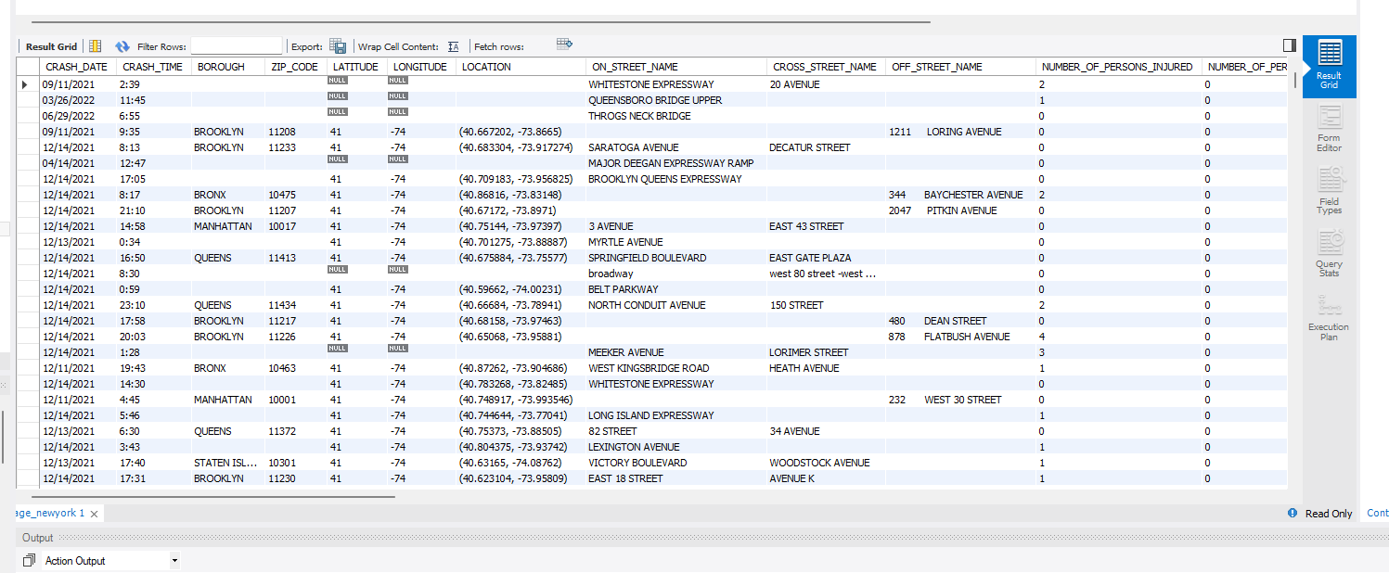

**PART 2:**

Transformation on all datasets:

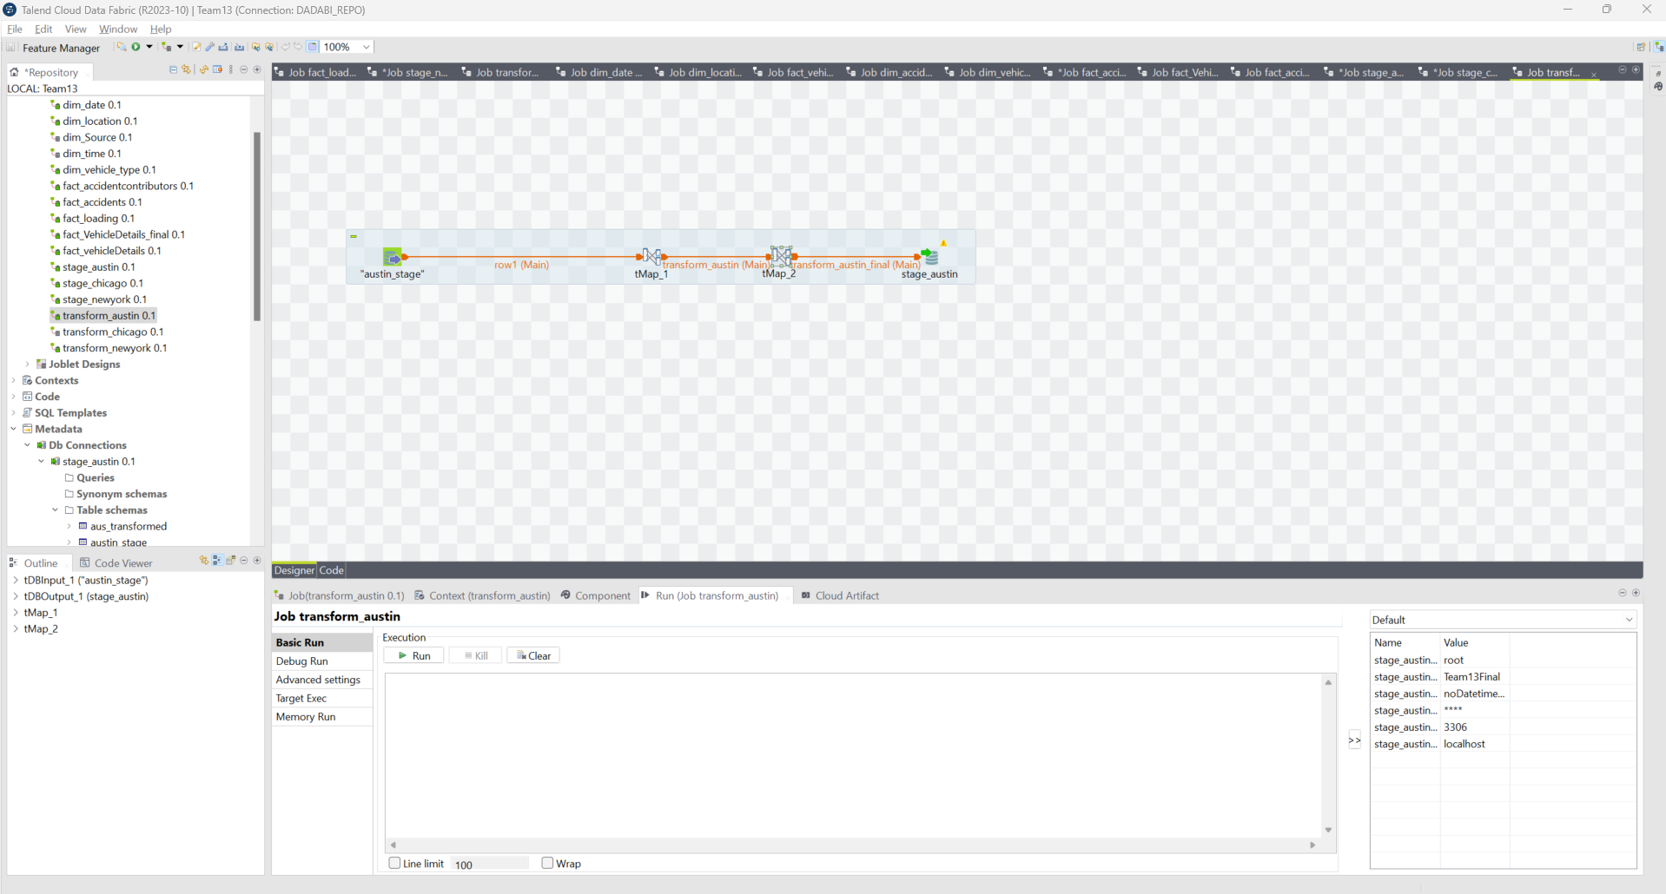

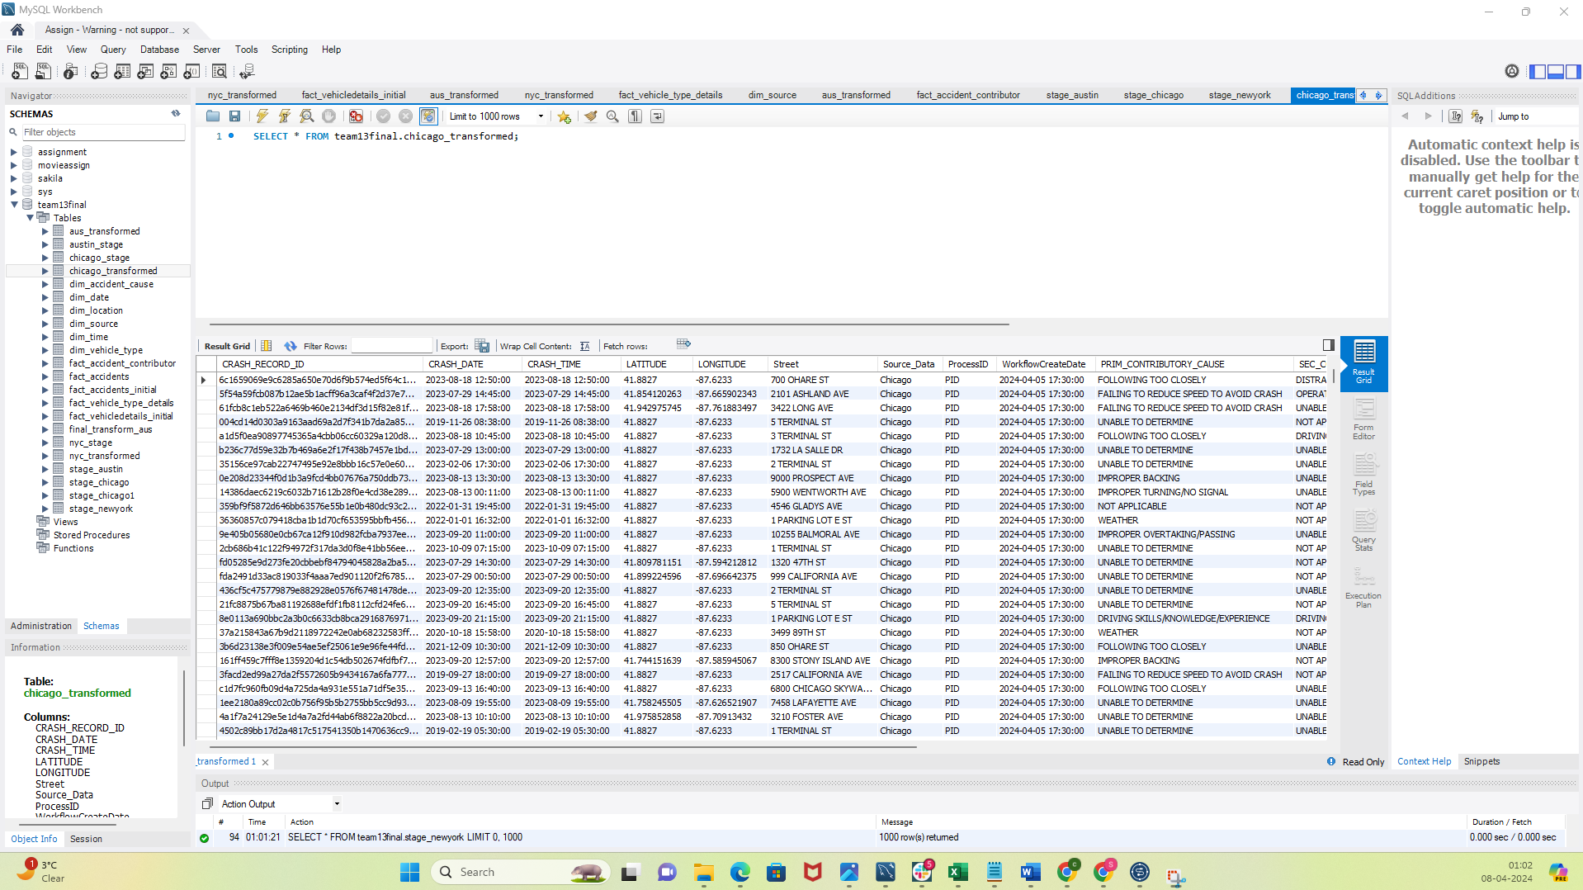

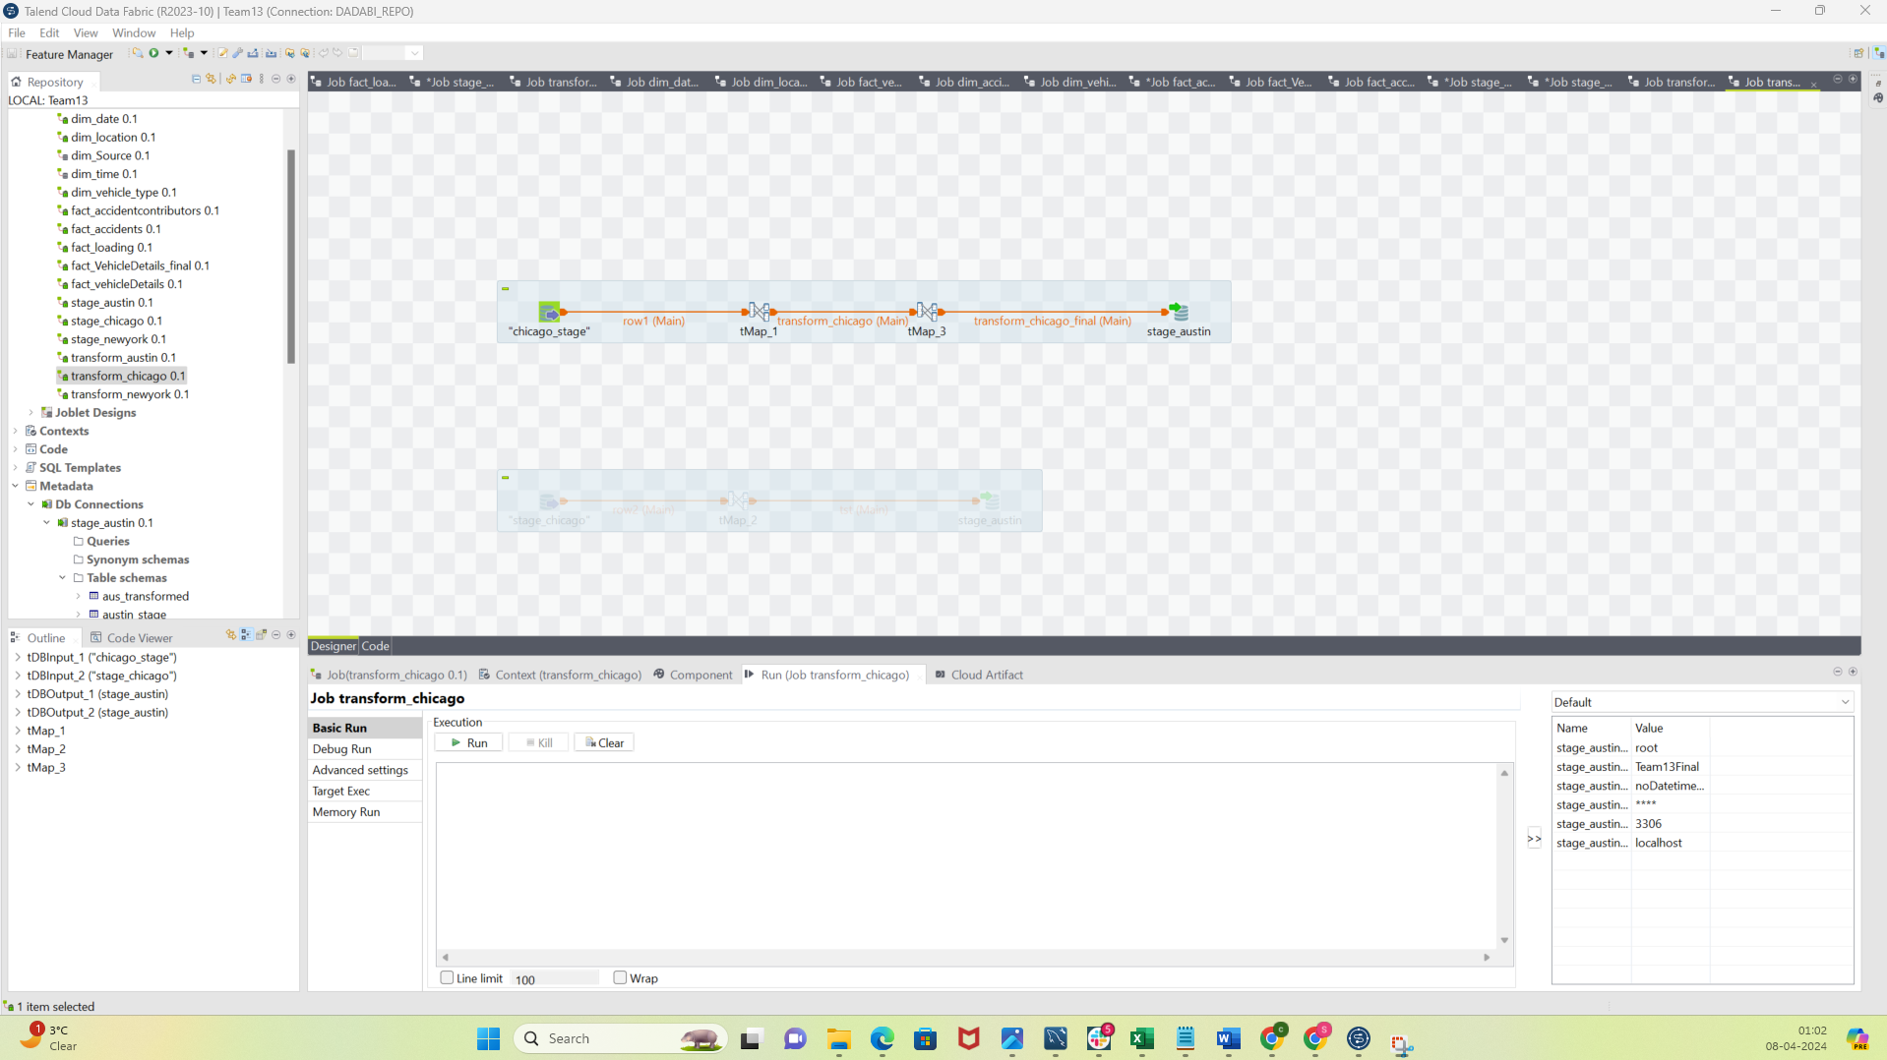

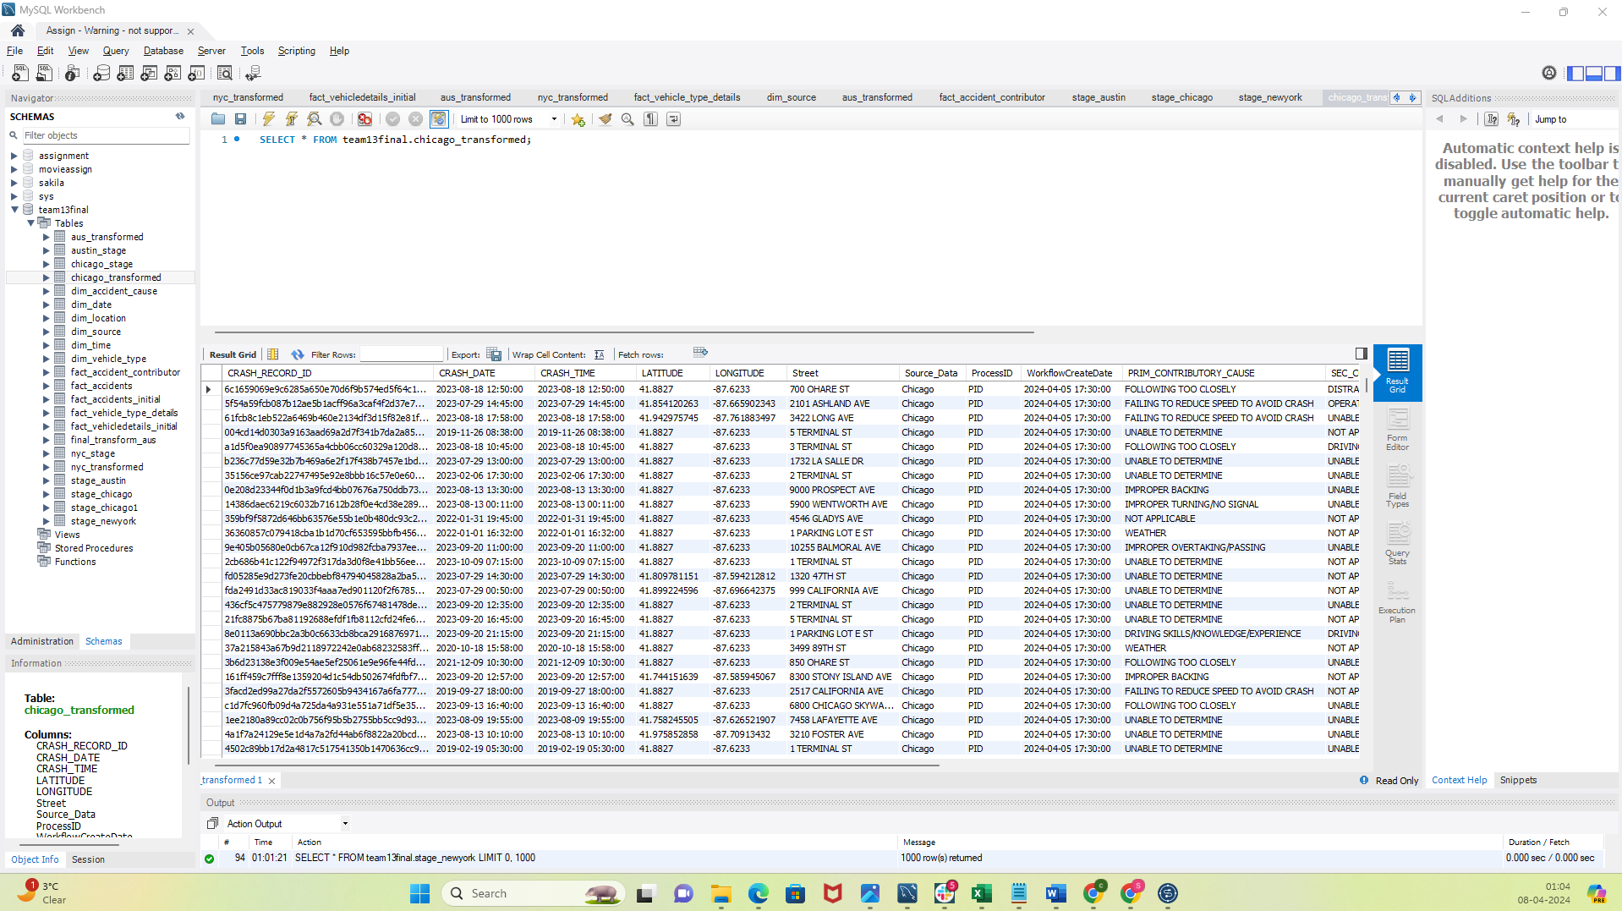

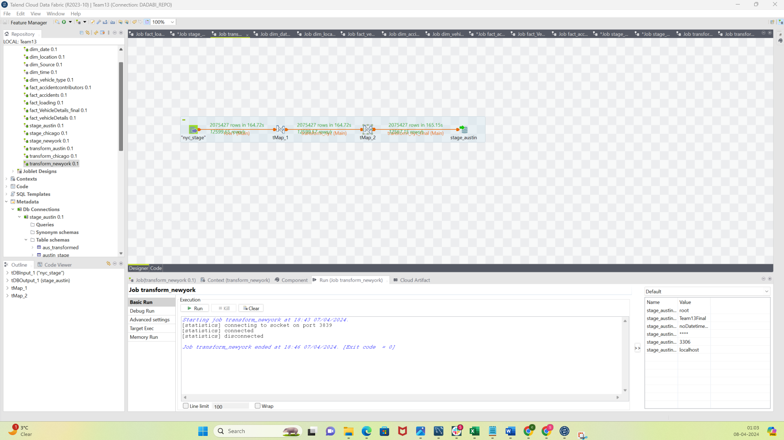

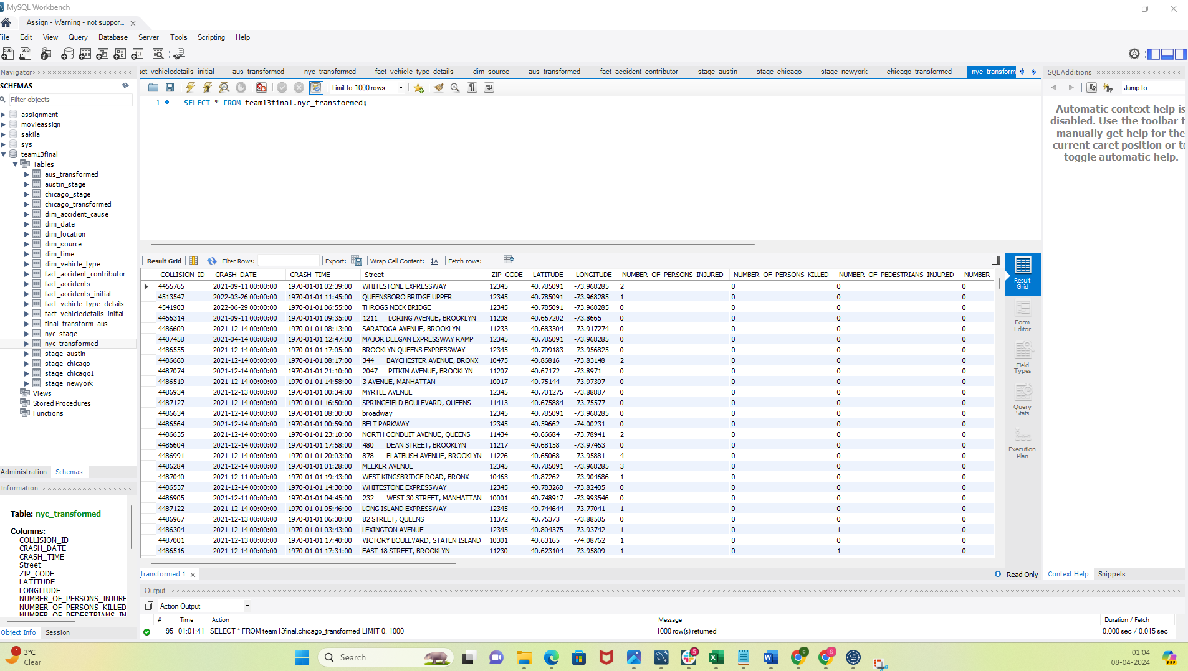

Loading Dimensions:

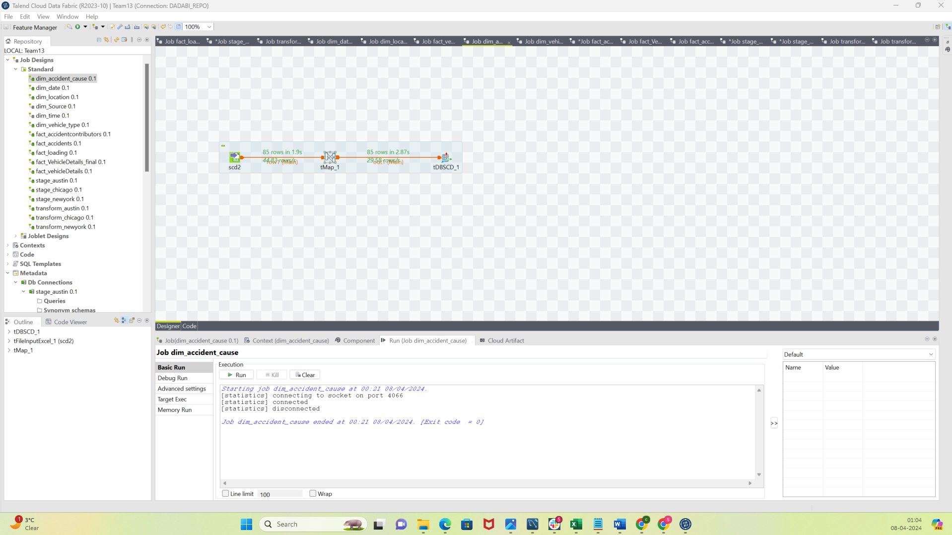

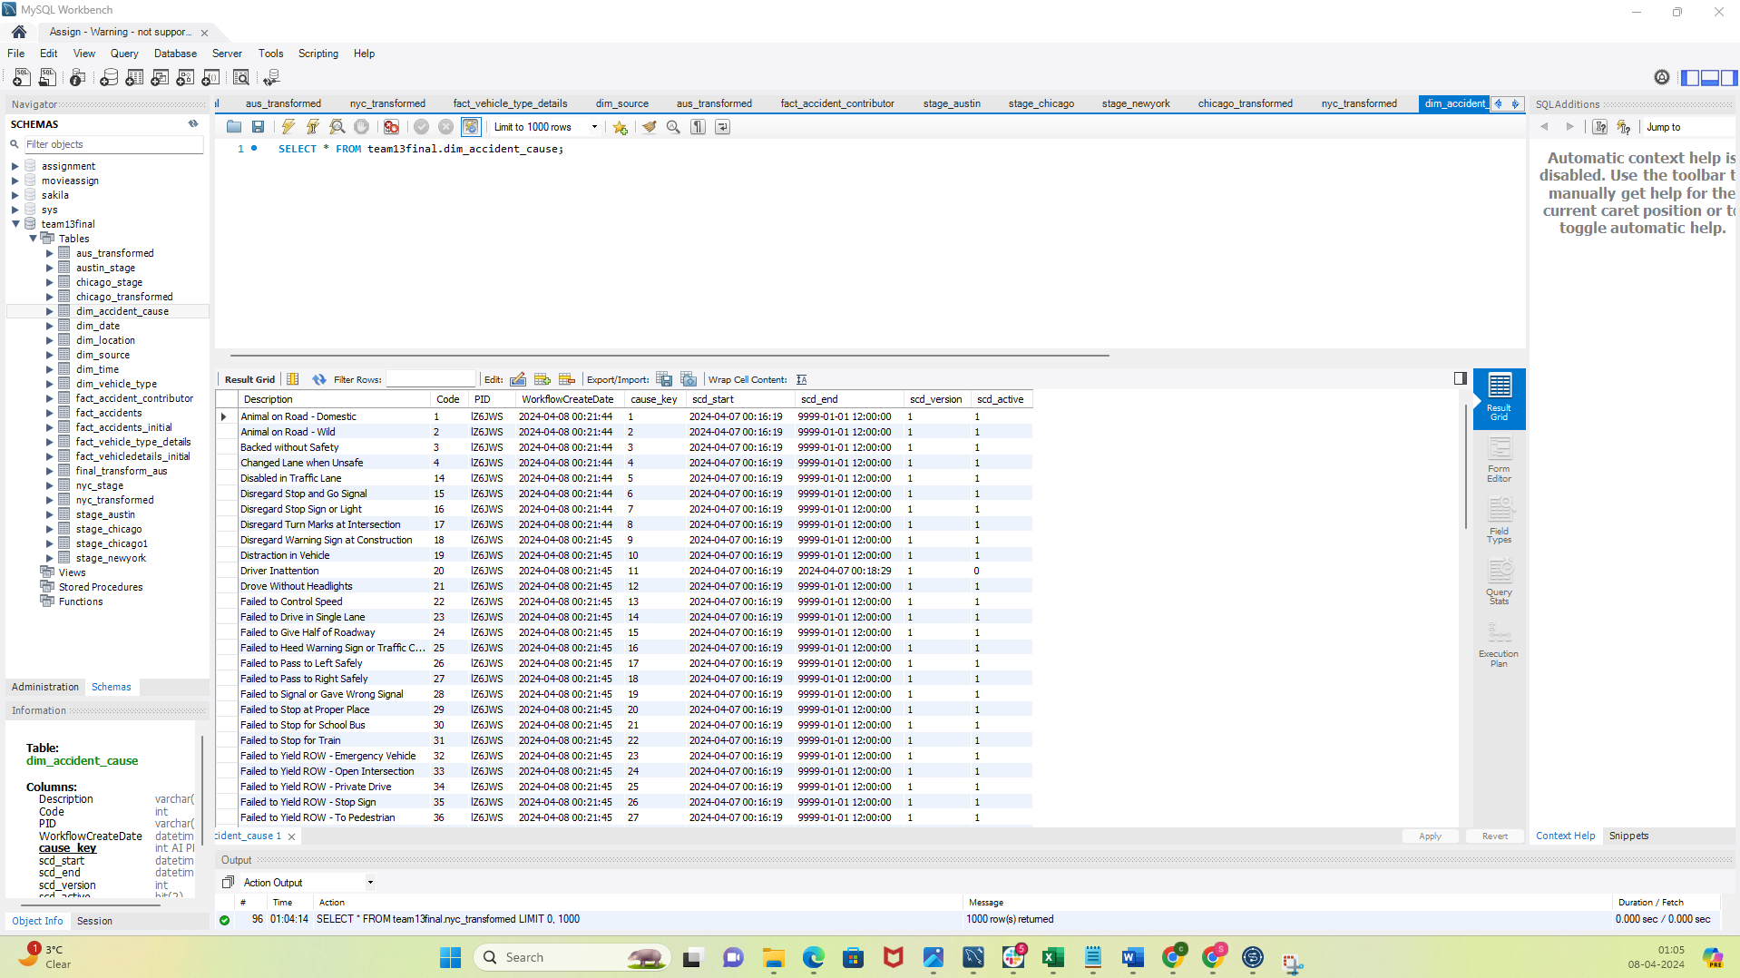

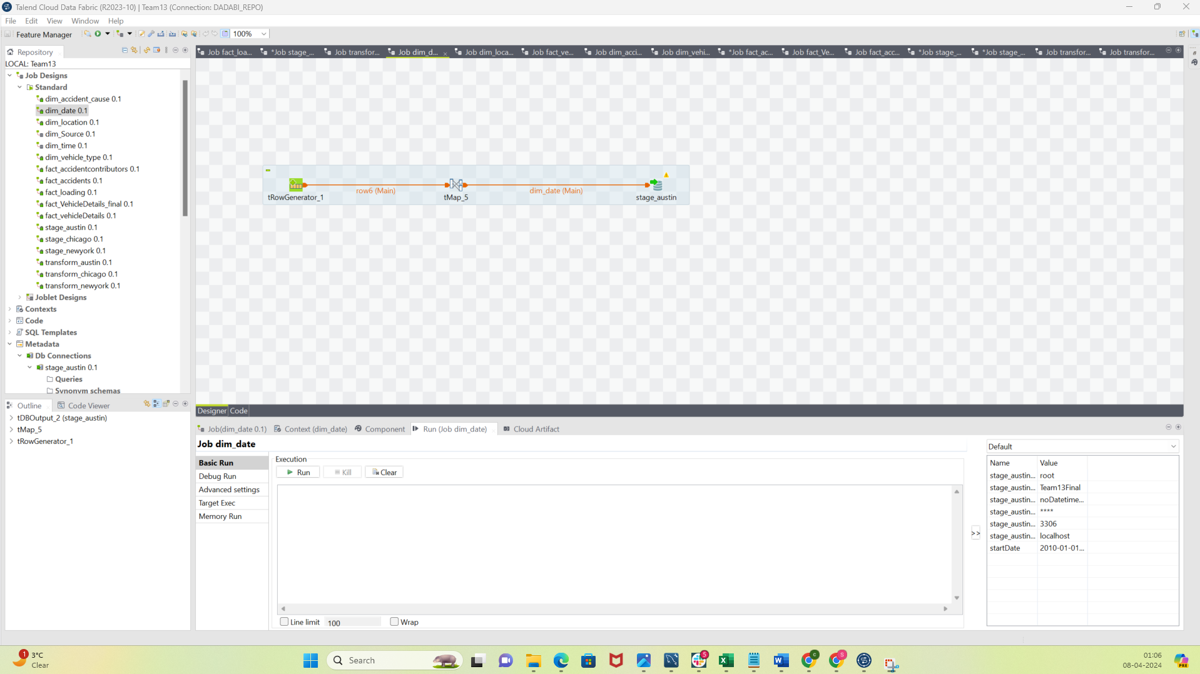

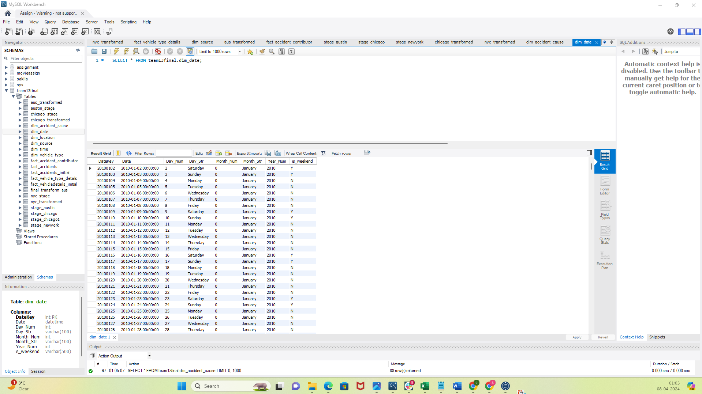

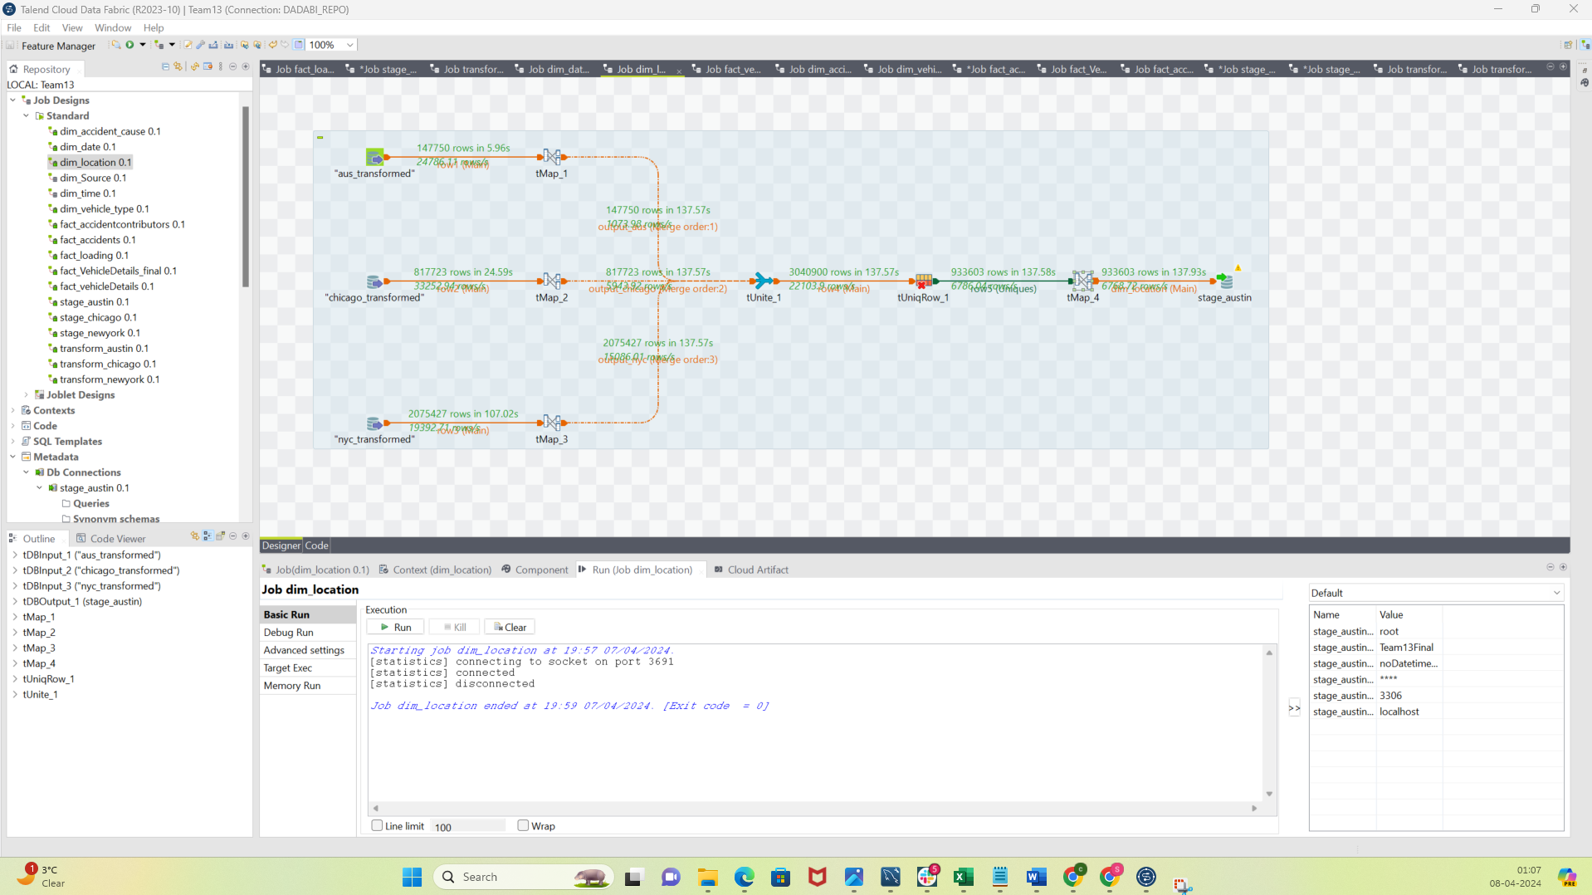

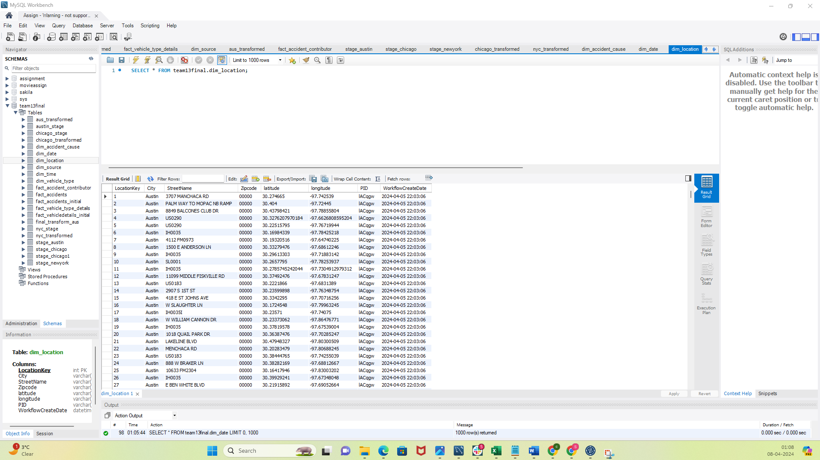

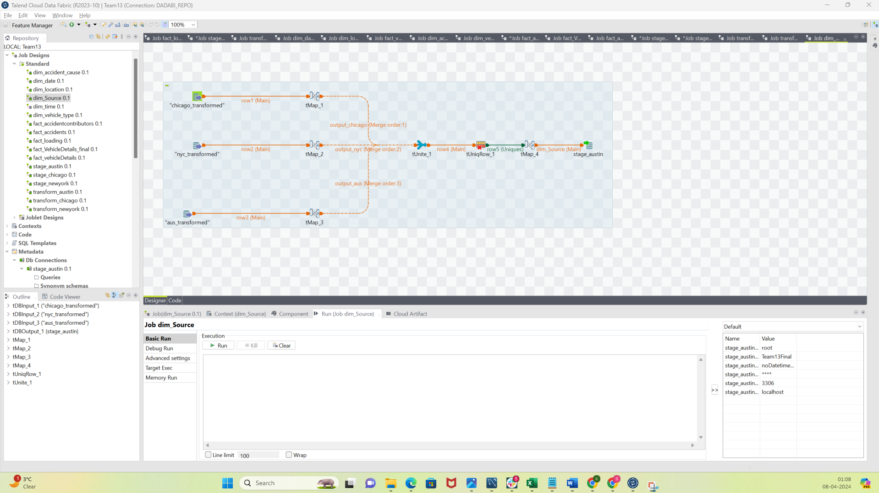

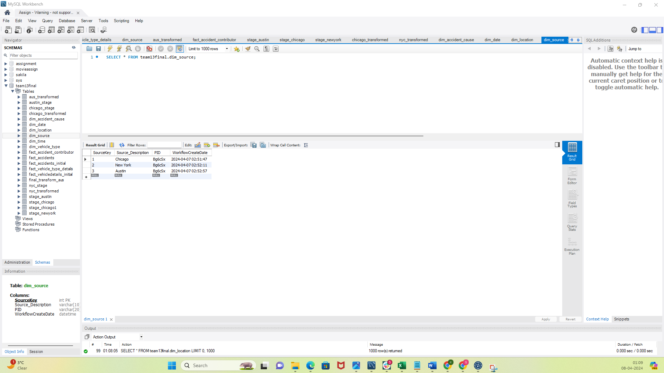

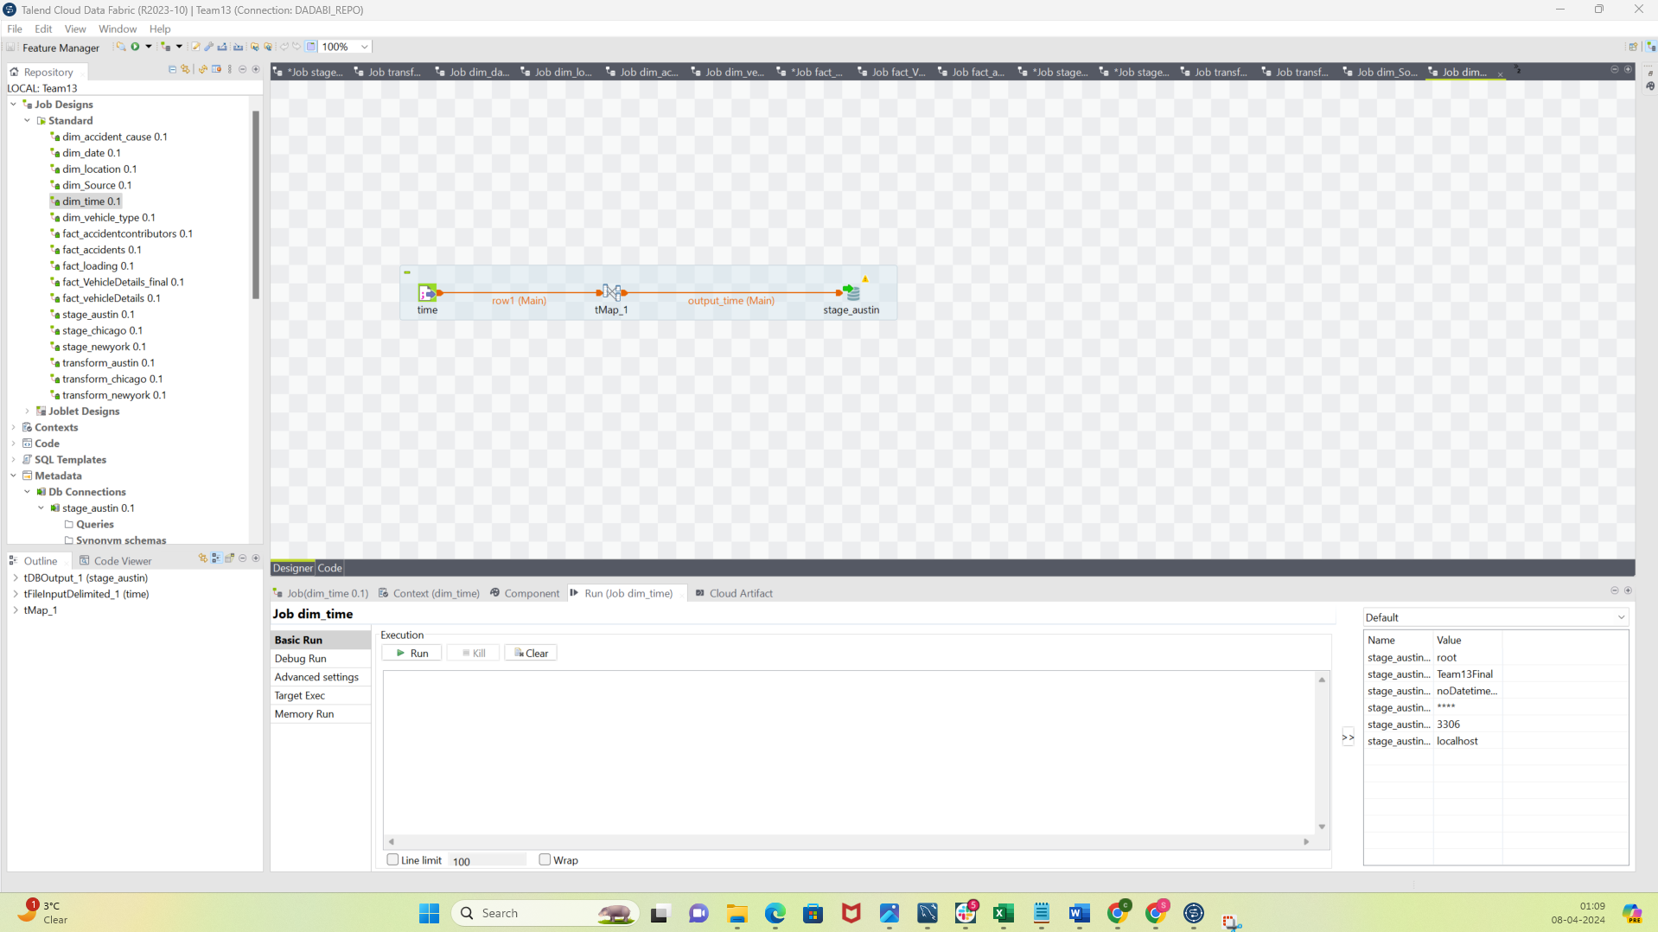

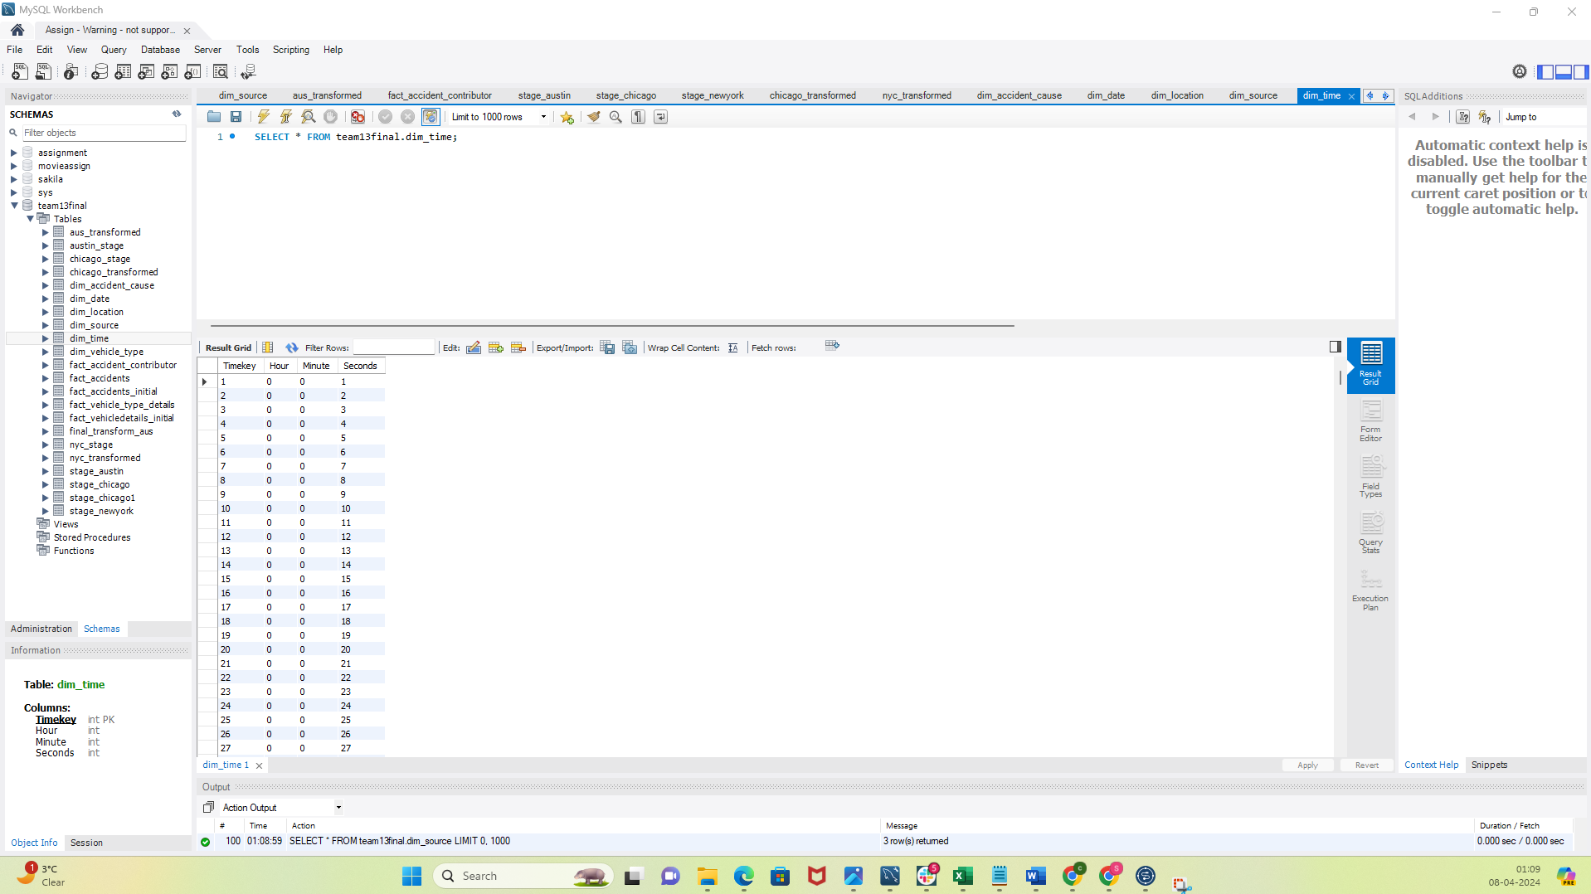

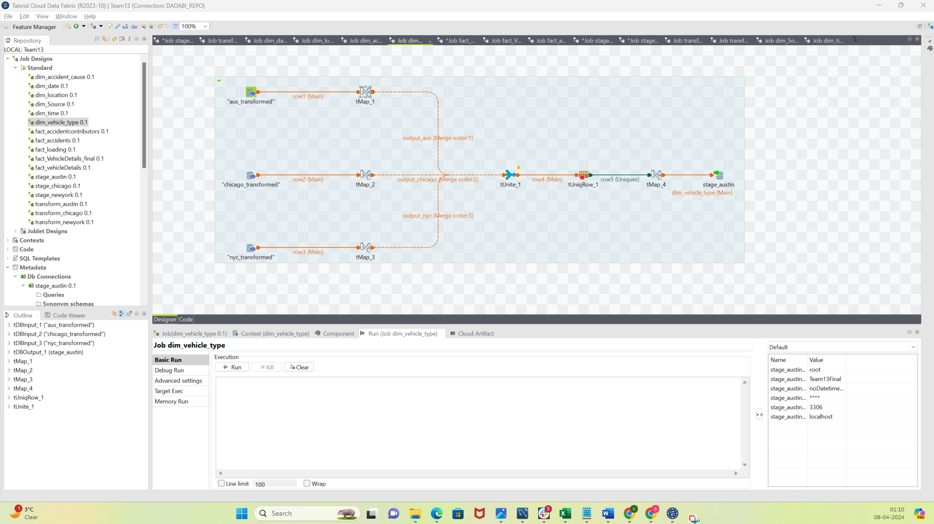

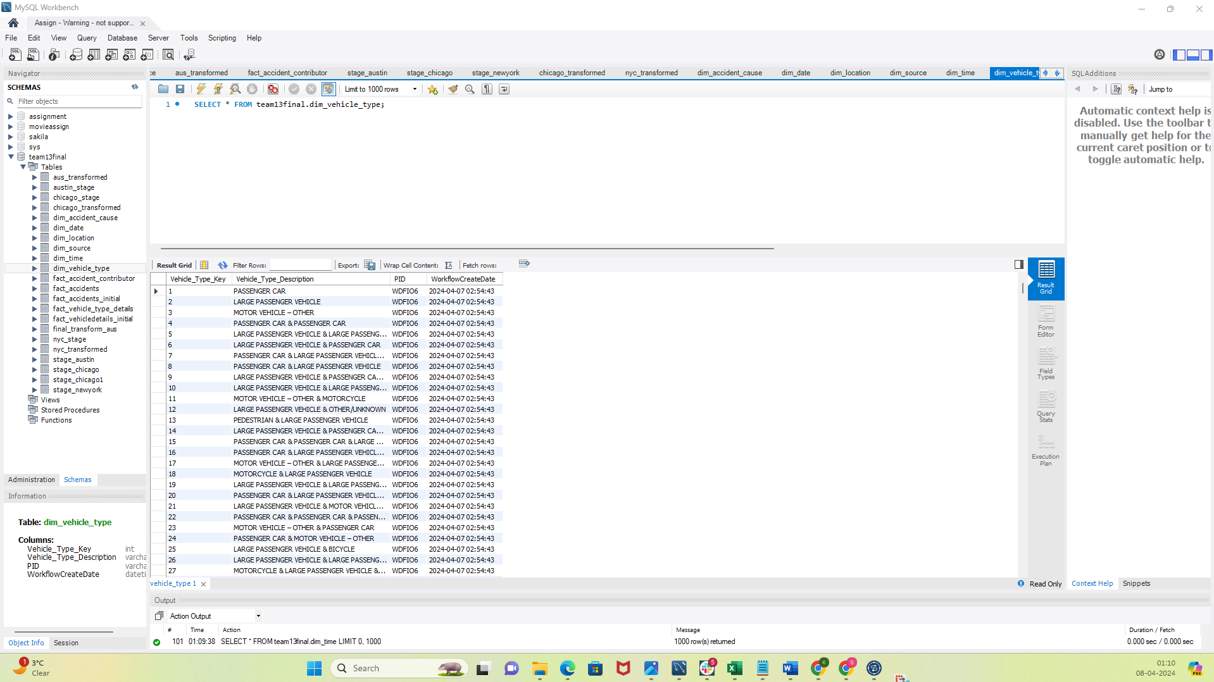

Loading Fact tables:

